

Software Requirement Specification (SRS)
Of
Training of Trainers (ToT) module
For Implementation of
Campus Management Software
at
World Skill Center (WSC)



Sustainable Outreach And Universal
Leadership (SOUL) Limited

Table of Content

A. Abstract 3
B. Introduction 3
C. Definition, Acronyms and Abbreviations 3
D. Overview of the Document 3
E. Scope of Education Module 4
F. WSC Student ToT Process Flow 5
G. WSC Student ToT Flowchart Description 6
H. Overall Screen and Its Description 7
I. Training of Trainers 9
1.1 Department 9
1.2 Programs 12
1.3 Course 14
1.4 Semester 17
1.5 Topic 19
Field List: 19
User: Roles & Permission : 20
1.6 Student 20
1.7 Student Group 26
1.8 Program Enrollment 29
1.9 Course Enrollment 33
1.10 Instructor 36
1.11 Course Schedule 39
1.12 Course Scheduling Tool 41
1.15 Student Attendance 43
1.16 Student Attendance Tool 45
1.17 Assignment 46
1.18 Assignment Upload 48
1.19 Exam Declaration 50
1.20 Exam Evaluation Plan 58
1.21 Exam Paper Setting 62
1.22 Criteria Wise Evaluation 65
1.23 Criteria Wise Evaluation Tool 67
1.24 Continuous Evaluation 69
1.25 Continuous Evaluation Tool 72
1.26 Final Exam Result 74
1.27 Final Result Declaration Tool 77
1.28 Cumulative Marksheet 79
1.29 Cumulative Marksheet Tool 82
1.30 ToT candidate list 85

Abstract
Software Requirements Gathering is one of the first phases of system development. This phase results in the Software Requirements Specification (SRS) document, which must contain a complete, concise, high-quality description of the system being considered.

Introduction
The World Skill Center (WSC) is a premier advanced skill training institute established by the Government of Odisha, Skill Development and Technical Education Department, through the Odisha Skill Development Authority (OSDA). The WSC will impart advanced skill training in eight trades from engineering and service sectors. WSC caters primarily to induct the best talent from ITIs and Polytechnics and train them to become globally employable in emerging areas such as "Industry 4.0". WSC is housed in a state-of-the-art, 18-storey, air-conditioned building with nearly half a million square feet of space in the heart of capital city of Bhubaneswar.

With the Implementation of campus management software for WSC the goal is to streamline the operations and functions of the campus by integrating various processes, such as admissions, course registration, academic progress tracking, and financial management, HRMS, Procurement and Inventory management, etc into a unified system. The implementation also aims at providing a user-friendly interface for all stakeholders, making it easier for them to access the necessary information and complete their tasks with ease. The modules to be covered during the implementation of the software includes:

Students Management Modules | Infrastructure Management
Academic System | Finance and Accounting System
Procurement & Inventory Management | Training and Placement
Human Resources Management System | Application Integration

Definition, Acronyms and Abbreviations

The following table explains the terms and abbreviations used in the document:

Abbreviation | Description
SRS | Software Requirements Specification
SLCM | Student Life Cycle Management
R | Rename - When a field is Renamed
N | New - When a New field is Added
D | Delete - When an Existing field is Deleted
NA | Not Applicable

Overview of the Document
This requirement document provides a detailed overview of the functional requirements of a project. It serves as a communication tool between stakeholders, including developers, project managers, and end-users. The purpose of this requirement document is to define and document the project's objectives, scope, and expectations, and to ensure that all stakeholders have a clear understanding of what the project entails.

This document covers all the functional requirements of the Training of Trainers (ToT) module of ERP Product. This module helps in organizing the entire Tot set-up, such as ToT Candidate Database, ToT Application Form, Fee Structure, Course Enrollment, ToT Candidate Attendance, Exam Evaluation, Certificate Generation, etc.

Scope of Education Module
- Courses and Subjects, Timetable preparation and management  ▪
- Class occurrence monitoring
- Class Attendance of students (Face recognition or any other automated mode).    ▪
- Results Analysis after declaration of results by WSC ▪
- Students Feedback mechanism on quality of teaching learning ▪ Internship, Training, Apprentice ▪
- Re-Admission Process after discontinuing in studies ▪
- Students Back paper tracking etc.
- Students Profile.  :Personal Information, Contact Details, Academic Details ▪
- Issue of Identity Card.  ▪
- Biometric Attendance (Face recognition) ▪
- Hostel Management (Hostel seat allotment, attendance, fees etc) ▪
- Scholarships.  ▪
- Rewards and achievements.  ▪
- Students’ Evaluation/remarks of Faculty.  ▪
- Students Exams records of all 6 semesters ▪
- Parent Enquiry/Alert/Messaging Management.  ▪
- Messaging System  ▪
- Students Grievance System etc.

Following functionalities are covered in this SRS document:

- Tot Candidate Details
- ToT Candidate Attendance
- ToT Exam Conducting
- Result Publication
- Certificate Generation

WSC Student ToT Process Flow

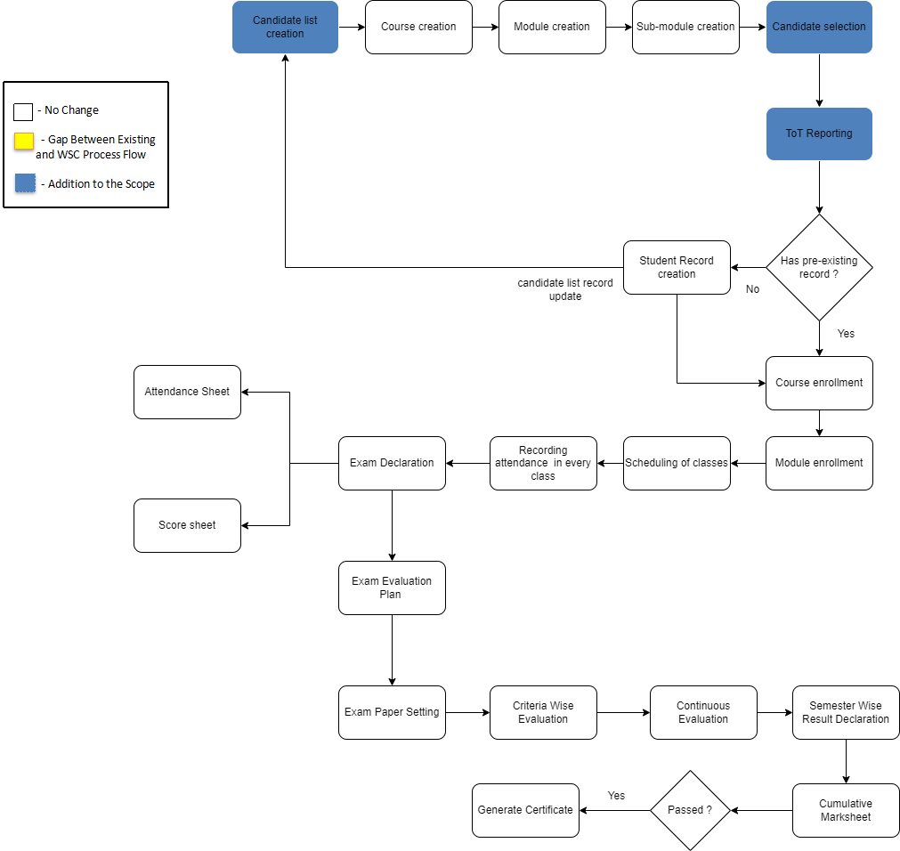

Figure 1 : ToT process flow

WSC Student ToT Process Flow Description

Candidate list creation

This allows the user to enter and maintain records of candidates who are eligible for the ToT program in the system.

Course selection

This allows the user to create and maintain records of course(s) that will be under the ToT program.

Module creation

This allows the user to create and maintain records of module(s) that will be under the ToT program.

Sub-module creation

This allows the user to create and maintain records of sub-module(s) that will be under the ToT program.

Candidate selection

This allows the user to select candidates for a ToT program from the records maintained in the candidates list.

ToT reporting

This allows the user to mark a candidate as present after they have reported on the day of reporting.

Student record creation

This allows the user to create a record of a candidate as a student under the ToT program which will later be used to do program enrollment.

Course enrollment

This allows the user to enroll a candidate with a record as a student into a course for their training.

Module enrollment

This allows the user to enroll a candidate with a record as a student into a module for their training.

Scheduling of classes

This allows the user to schedule the classes for a module under the ToT program.

Recording attendance in every class

This allows the user to record attendance of candidates during each class under the ToT program.

Exam declaration
This allows the user to declare an exam fro various program in accordance with the ‘Academic Calendar’ template which was used during the start of each session.

Attendance sheet

Attendance sheets allows the user to maintain and mark attendance of students present in the examination room.

Score sheet

Score sheets are used to record the marks obtained by each student in an examination. The score sheet includes the name of the student, marks obtained in each subject and the total marks achieved by the student.

Exam evaluation plan

An exam evaluation plan is a schedule to conduct the examination/assessment of a particular course for a group of students studying that course in an on-going academic term.

Criteria wise evaluation

Criteria wise evaluation allows to create an evaluation for a particular assessment criteria in a course for a student enrolled in that course

Continuous evaluation

It is used to assess the assessment criteria done for a course for an individual student.

Semester wise result declaration

It is used to evaluate the final assessment of a student for a particular semester.

Cumulative Marksheet

Cumulative marksheet is a compilation of all the semesters with their program grades in a single certificate. The cumulative marksheet will have a list of subjects, grades obtained and CGPA (Cumulative Grade Point Average) and also details of students such as their roll number, name, age, date of birth and program enrollment.

Generate Certificate

This allows the user to generate a certificate for the candidates after they have met all the criterias required for a certificate.

List of Screens and their Descriptions
The following tables lists the pages used in ToT module :

Sl no | Screen Name | Description
 | Department | A Department is a specialized functional area or a division within an organization.
 | Programs | The Programs document will hold all the data related to the programs.
 | Course | A program will have an educational curriculum defined by user institute to streamline the learning process and goals in each subject or module.
 | Semester | A semester is individual part of a program. A semester system divides the academic year into different sessions which have various course enrollments enlisted in them.
 | Topic | A Topic is a sub unit of a Module and will contain all the contents related to the topic.
 | Student | The Student document will hold all the data related to the students.
 | Student Group | The Student Group allows you to create a group of students for different classes for the ongoing Academic Year.
 | Program Enrollment | Program Enrollment is the record of enrollment of a student in a given program and chosen courses for a particular Academic Term.
 | Course Enrollment | Course Enrollment is the record of enrollment of a student in a given program and chosen courses for a particular Academic Term.
 | Instructor | An instructor is an employee who will be responsible for teaching a particular topic or course to the students.
 | Course Schedule | A course schedule is a specialized functional area or a division within the Groups and schedule.
 | Course Scheduling Tool | The Course Scheduling Tool allows a user to create Course Schedules in bulk for the particular Course.
 | Student Attendance | The Student Attendance allows you to keep track and mark the attendance of a student for a day. Attendance records can be created against students on a daily basis.
 | Student Attendance Tool | The Student Attendance Tool allows user to bulk update the Attendance for Students based on Student Group and Course Schedule.
 | Assignment | In Assignment Screen Trainers can easily provide assignment to their respective students, so that it gives a strong bonding between the students and the trainers.
 | Assignment upload | In Assignment Upload Screen Students can easily upload their assignment and it will securely go to their respective trainers.
 | Exam declaration | The Exam Declaration will allow user to declare an exam for various programs in accordance with the ‘Academic Calendar’ template which was used during the start of each session.
 | Exam evaluation plan | An Exam Evaluation Plan is a schedule to conduct the examination/assessment of a particular course for a group of students studying that course in an on-going academic term.
 | Exam paper setting | The Exam Paper Setting is used to prepare paper setting schedules and plan for paper setters and moderators for a particular exam declaration.
 | Criteria wise evaluation | Criteria Wise Evaluation allows us to create an evaluation for a particular assessment criterion in a course for a student enrolled in that course.
 | Criteria wise evaluation tool | Criteria Wise Evaluation Tool helps in entering marks earned by the students in a semester for a particular course and particular assessment criteria.
 | Continuous evaluation | Continuous Evaluation is used to assess the Assessment Criteria done for a course for an individual student.
 | Continuous evaluation tool | Continuous Evaluation Tool is used to assess the Assessment Criteria done for a course for an individual student.
 | Final exam result | Final Exam Result is used to evaluate the final assessment of a student for a particular semester.
 | Final result declaration tool | Final Result Declaration Tool is used to declare the final exam results for a particular group/batch of students in a semester.
 | Cumulative marksheet | Cumulative Marksheet is a compilation of all the semesters with their grades in a single certificate. The Cumulative marksheet will have a list of subjects, grades obtained and CGPA (Cumulative Grade Point Average). And also details of students, such as roll number, name, age and date of birth, program enrollment.
 | Cumulative marksheet tool | Cumulative Marksheet is a compilation of all the semesters with their grades in a single certificate. The Cumulative marksheet will have a list of subjects, grades obtained and CGPA (Cumulative Grade Point Average). And also details of students, such as roll number, name, age and date of birth, program enrollment.
 | ToT candidate list | This screen is used for creating and maintaining records of eligible candidates
 | ToT candidate selection | This screen is used for selecting candidates for trainings from the maintained ToT candidate list
 | ToT candidate reporting | This screen is used for marking a candidate as present on the date of reporting

Training of Trainers

Following are the screens used to achieve the functionalities of ToT.

1.1 Department

General Description

The following table describes overall information about this screen:
Description |  | - A Department is a specialized functional area or a division within an organization.  - User will configure the Departments, set Leave Block List and also Leave and Expense Approvers for the same.  - Department is a tree-structured master, which means user can create parent departments and sub-departments as shown below
Navigation | Home > Admission > Masters > Department
Pre-requisites | The system should have records in the following screen  - Company  - Leave Block List
Existing Screen Name | Department
New Screen Name | No change

Screenshot

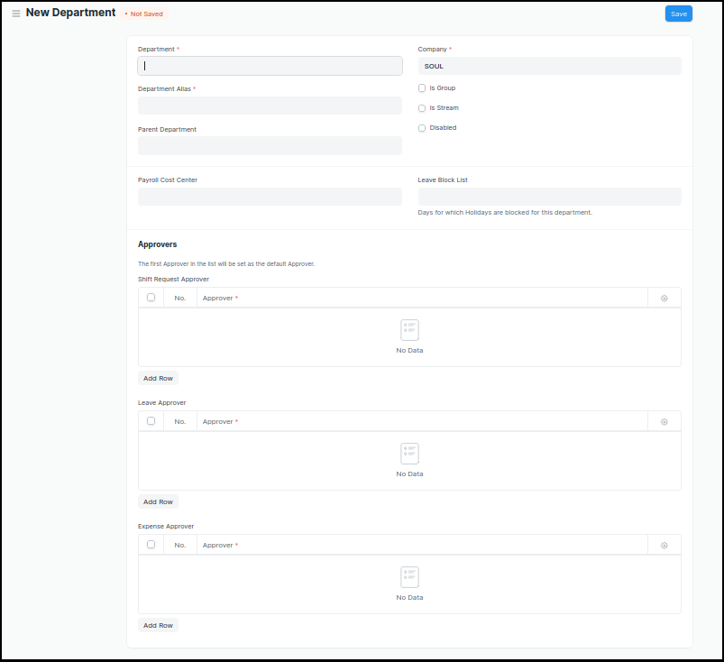
Figure 2 : Department Screen

Field List

The following table describes the UI fields present in this screen :

ID | Label | Type | Mandatory | Validation/ Action | Remarks | R = Rename  N= New  D= Delete
1 | Department | Text Field | Yes
2 | Parent Department | Link Field
3 | Company | Link Field | Yes | Link Fields to Master Screen Company | Default company name will be fetched
4 | Is Group | Checkbox |  | If checked the department will be grouped under a parent department
5 | Is Stream | Checkbox |  | If checked the department will be considered as a stream E.g (Commerce, Arts, Etc)
6 | Disabled | Checkbox |  | If checked, the department record will not be able to visible in any transaction
7 | Payroll Cost Center | Link Field |  |  | Not Applicable for Admission Module
8 | Leave Block List | Link Field |  |  | Not Applicable for Admission Module
10 | Leave Approver | Table |  |  | Not Applicable for Admission Module
11 | Expense Approver | Table |  |  | Not Applicable for Admission Module
12 | Shift Request Approver | Table |  |  | Not Applicable for Admission Module

User: Roles & Permission

The following table describes the users and their roles and permissions for the screens :
ID | Role | Select | Read | Write | Create | Delete | Submit | Cancel | Amend
1 | ToT coordinator/director | Yes | Yes | Yes | Yes | Yes | NA | NA | NA
2 | ToT coordinator/administrator | Yes | Yes | Yes | Yes | No | NA | NA | NA
3 | ToT assistant coordinator/trainer | No | Yes | No | No | No | NA | NA | NA

1.2 Programs

General Description

The following table describes overall information about this screen:

Description | - A program will have an educational curriculum defined by user institute to streamline the learning process and goals in each subject or module.  - For example, Mechatronics would be a program taught at the institute that will have various modules within
Navigation | Home > Admission >Masters > Programs
Pre-requisites
Existing Screen Name | Programs
New Screen Name | Course

Screenshot

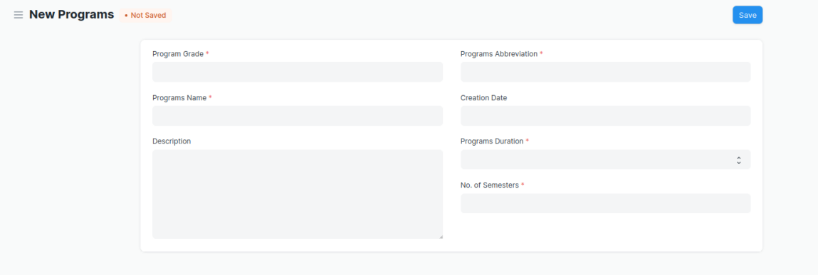
Figure 3 : Programs Screen

Field List

The following table describes the UI fields present in this screen :

ID | Label | Type | Mandatory | Validation / Action | Remarks | R = Rename  N= New  D= Delete
1 | Program Grade | Link Field | Yes | Links with Program Grade Screen |  | (R) Course Grade
2 | Programs Name | Data | Yes |  |  | (R) Course Name
3 | Department | Link Field | Yes | Links with Department Screen
4 | Description | Small Text
5 | Programs Abbreviation | Text | Yes |  |  | - Course  Abbreviation
6 | Creation Date | Date
7 | Programs Duration | Dropdown | Yes | 1 Year  2 Years  3 Years  4 Years  5 Years  6 Years  7 Years  8 Years  9 Years  10 Years |  | (R) Course Duration
8 | No. of Semesters | Number | Yes
9 | Add Semesters | Button |  | After saving the record, this button  Will be visible to the user.
Semesters Table
11 | Semesters | Link Field |  | Semester will automatically created after clicking on the button Add Semesters w.r.t. the Program Abbreviation Name
12 | Semesters | Text |  | Semesters name auto fetch from semesters screen

User: Roles & Permission

The following table describes the users and their roles and permissions for the screens :

ID | Role | Select | Read | Write | Create | Delete | Submit | Cancel | Amend
1 | ToT coordinator/director | Yes | Yes | Yes | Yes | Yes | NA | NA | NA
2 | ToT coordinator/administrator | Yes | Yes | Yes | Yes | No | NA | NA | NA
3 | ToT assistant coordinator/trainer | No | Yes | No | No | No | NA | NA | NA

1.3 Course

General Description

The following table describes overall information about this screen:

Description | - A module can be considered as a subject or a part of an educational program which is to be taught for a term  - For example, if for a particular term, Mechatronics is a Course taught in the institute, then Pneumatics would be a Module covered under the Course.  - A module will have a set of sub module that are to be covered under its scope.
Navigation | Home > Admission > Masters > Module
Pre-requisites | - Department  - Course Grade  - Course  - Semeste  - Assessment Criteria
Existing Screen Name | Course
New Screen Name | Module

Screenshot

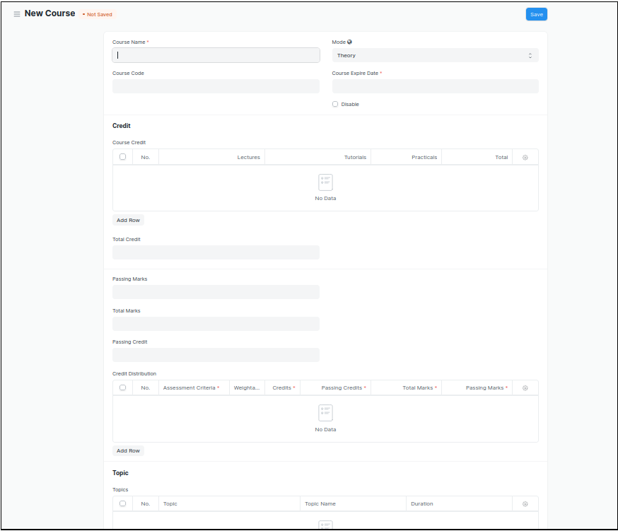
Figure 4 : Course Screen

Field List

The following table describes the UI fields present in this screen :

ID | Label | Type | Mandatory | Validation / Action | Remarks | R = Rename  N= New  D= Delete
1 | Course Name | Text | Yes |  |  | ( R ) Module Name
2 | Course Code | Text | Yes |  |  | ( R ) Module Code
3 | Mode | Dropdown |  | Theory  Practical  Both
4 | Course Expire Date | Date | Yes |  |  | ( R ) Module Expire Date
5 | Disable | Checkbox |  | If Checked, then course should not be visible in any transaction.
Course Credit
6 | Lectures | Float |  |  |  | ( D )
7 | Tutorials | Float |  |  |  | ( D )
8 | Pacticals | Float |  |  |  | ( D )
9 | Total | Float |  | Total Will be auto calculate  The sumof L, T & P |  | ( D )
10 | Total Credit | Float |  | Total Credit Will be auto calculate  the sum of L, T & P |  | ( D )
11 | Passing Marks | Float
12 | Total Marks | Float
13 | Passing Credit | Float |  |  |  | ( D )
Credit Distribution
14 | Assessment Criteria | Link Field | Yes
15 | Weightage | Percentage | Yes
16 | Credits | Float | Yes |  |  | ( D )
17 | Passing Credits | Float | Yes |  |  | ( D )
18 | Total Marks | Float | Yes | Weightage will be auto fetched in Total Marks
19 | Passing Marks | Float | Yes
Topic
20 | Topic | Link Field |  | Links with Topic Screen
21 | Topic Name | Text |  | Auto fetch the Topic Name when topic is entered
22 | Duration | Duration
23 | Attach lesson plan | Attach |  | - On attachment a dialogue box will be popup where user can attach the files, take the picture with the help camera and can link any URL.  - If photos or images attached then the size will be maximum 200 kb.
24 | Action/ Add to Semester | Action Button |  | A popup will open, you need to choose the semester name, where you want to Link .

User: Roles & Permission

The following table describes the users and their roles and permissions for the screens :
ID | Role | Select | Read | Write | Create | Delete | Submit | Cancel | Amend
1 | ToT coordinator/director | Yes | Yes | Yes | Yes | Yes | NA | NA | NA
2 | ToT coordinator/administrator | Yes | Yes | Yes | Yes | No | NA | NA | NA
3 | ToT assistant coordinator/trainer | No | Yes | No | No | No | NA | NA | NA

1.4 Semester

General Description

The following table describes overall information about this screen:
Description | - A semester is individual part of a program. A semester system divides the academic year into different sessions which have various course enrollments enlisted in them.  - For example, a program in Mechatronics can consist of 2 semesters.
Navigation | Home > Admission > Masters > Semester
Pre-requisites | - Department  - Course Grade  - Course
Existing Screen Name | Semester
New Screen Name | No change
Screenshot

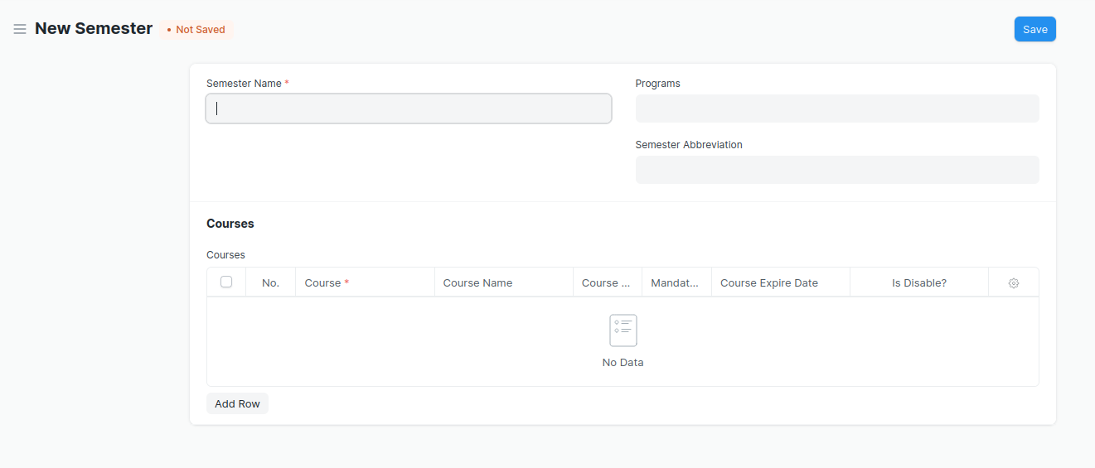
Figure 5 : Semester Screen

Field List

The following table describes the UI fields present in this screen :

ID | Label | Type | Mandatory | Validation / Action | Remarks | R = Rename  N= New  D= Delete
1 | Semester Name | Text | Yes
2 | Department | Link Field
3 | Programs | Link Field | Yes | Program Name will come in a drop down on the basis of Department Name. |  | ( R )Course
4 | Semester Abbreviation | Text
Courses Table | Programs Abbreviation | Text | Yes |  |  | - Course  Abbreviation
5 | Course | Link Field | Yes | Links with Course Screen |  | ( R ) Module
6 | Course Name | Text |  | Auto fetched when course is entered |  | ( R ) Module
7 | Course Code | Text |  | Auto fetched when course is entered |  | ( R ) (Module)
8 | Mandatory | Checkbox
9 | Modes | Dropdown |  | Auto fetched when course is entered
10 | Course Expire Date | Date |  | Auto fetched when course is entered |  | ( R ) Module
11 | Is Disable? | Checkbox |  | Auto fetched when course is entered

User: Roles & Permission

The following table describes the users and their roles and permissions for the screens :

ID | Role | Select | Read | Write | Create | Delete | Submit | Cancel | Amend
1 | ToT coordinator/director | Yes | Yes | Yes | Yes | Yes | NA | NA | NA
2 | ToT coordinator/administrator | Yes | Yes | Yes | Yes | No | NA | NA | NA
3 | ToT assistant coordinator/trainer | No | Yes | No | No | No | NA | NA | NA

1.5 Topic

General Description

Description : | A Topic is a sub unit of a Module and will contain all the contents related to the topic.
Path : | Home > Admission > Masters > Topic
Pre-requisites :
Existing Screen Name | Topic
New Screen Name | No change

Screenshot
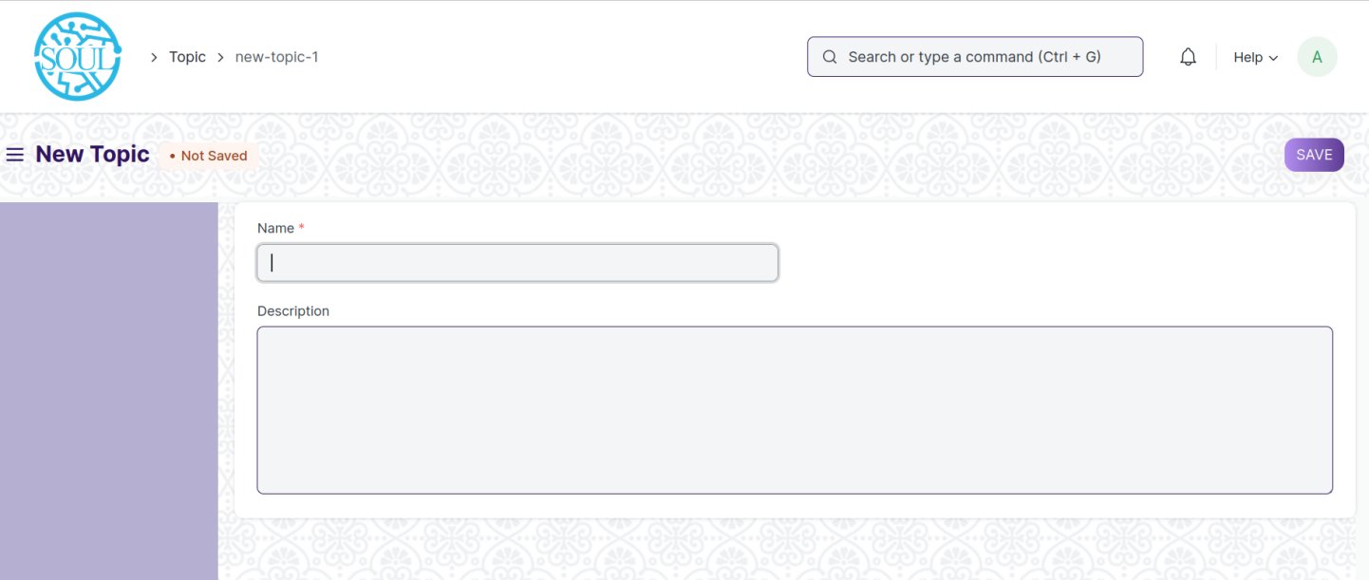
Figure 6 : Semester Screen

Field List:

The following table describes the UI fields present in this screen :

ID | Label | Type | Mandatory | Validation / Action | Remarks | R= Rename  N= New  D= delete
1 | Name | Data | Yes
2 | Topic content | Table
3 | Description | Small Text
4 | Hero Image | Attach Image

User: Roles & Permission :

The following table describes the users and their roles and permissions for the screens :

ID | Role | Select | Read | Write | Create | Delete | Submit | Cancel | Amend
1 | ToT coordinator/director | Yes | Yes | Yes | Yes | Yes | NA | NA | NA
2 | ToT coordinator/administrator | Yes | Yes | Yes | Yes | No | NA | NA | NA
3 | ToT assistant coordinator/trainer | No | Yes | No | No | No | NA | NA | NA

1.6 Student

General Description

The following table describes overall information about this screen:

Description | - The Student document will hold all the data related to the student such as their personal information, Photo, Date of Birth, Address, etc.  - This form will also contain any additional details, like the Student's Guardian and Sibling details.  - Note : The student is enrolled in a program when the application (Student Application) is approved. Once the enrollment is done, the Student Applicant status is updated to Admitted
Navigation | Home > Admission > Student & Instructor > Student
Pre-requisites

Screenshot

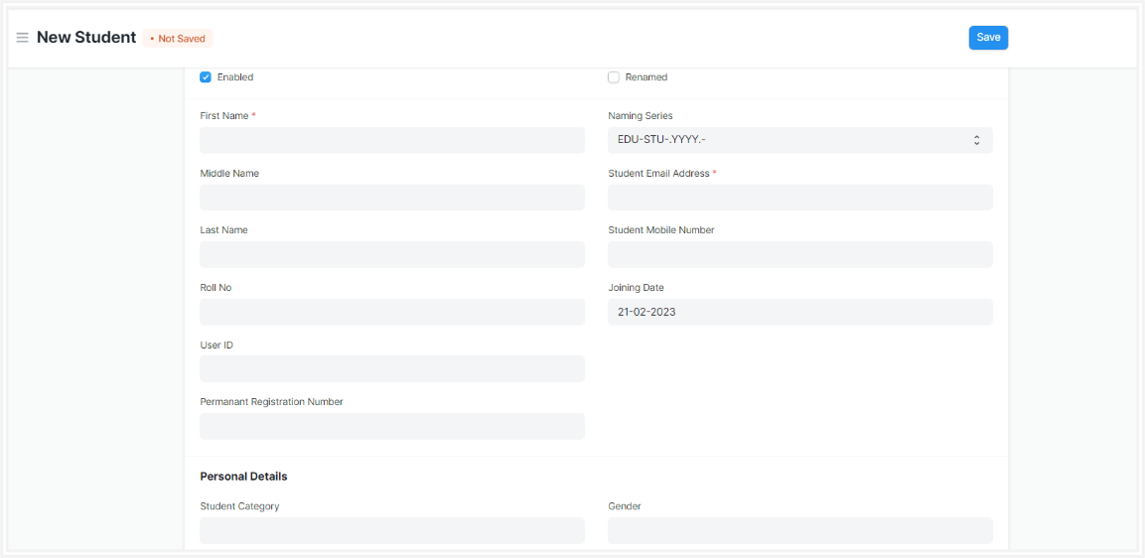
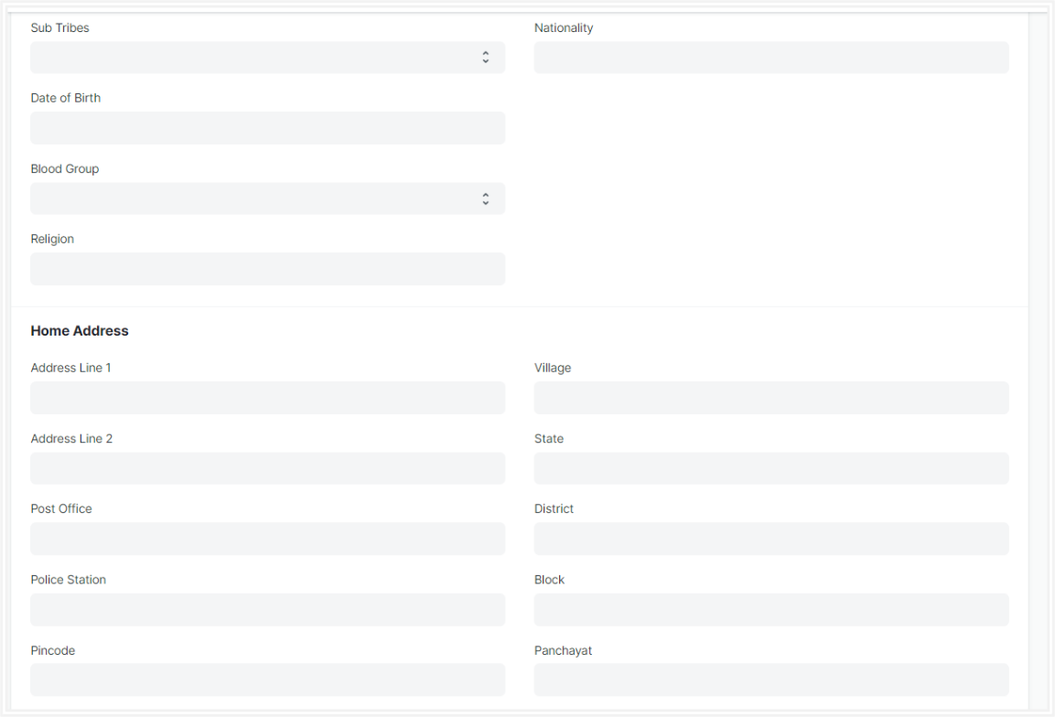
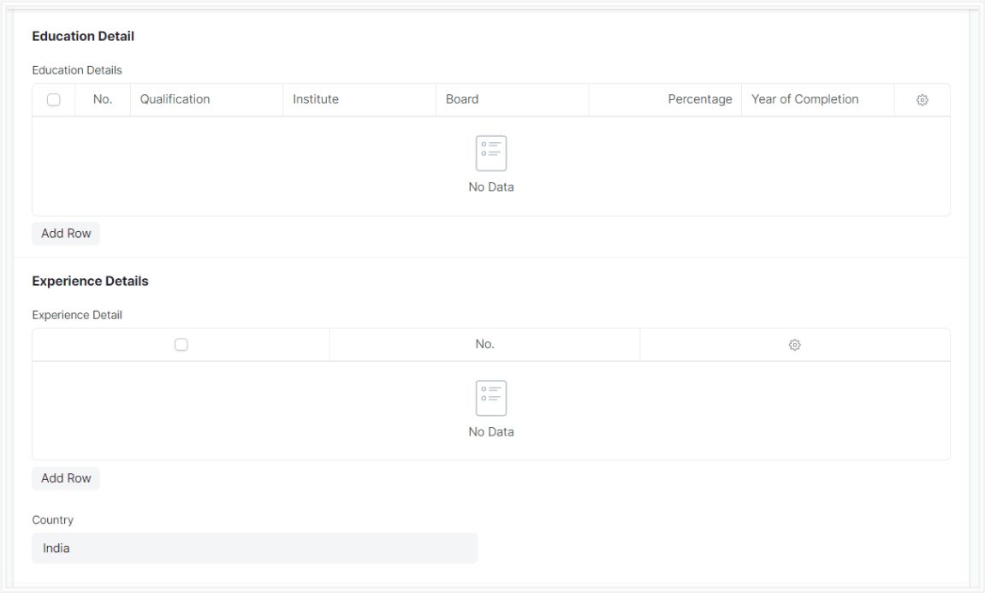
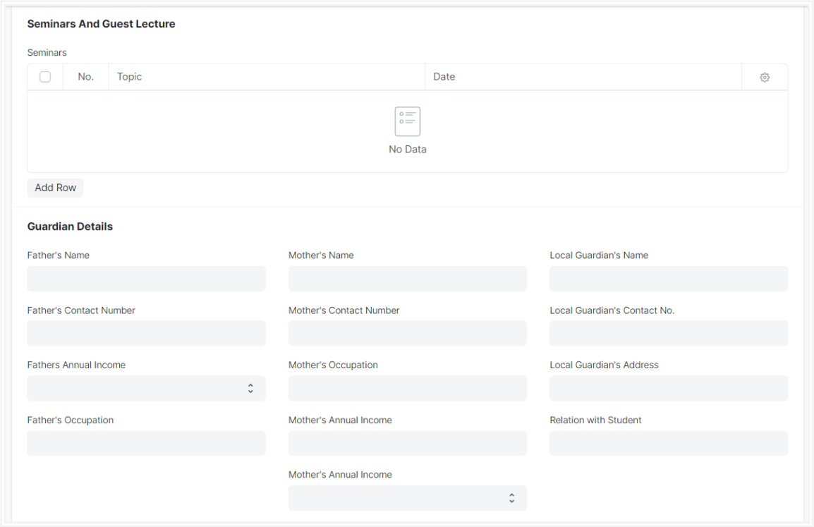
Figure 7 : Student Screen

Field List

The following table describes the UI fields present in this screen:

ID | Label | Type | Mandatory | Validation / Action | R = Rename  N= New  D= Delete
 | Enabled | Checkbox |  | Student by default would  always be enabled.  Once user have recorded  the Student's Exit Details,  user must unchecked this box to disable the student.
1 | First Name | Text | Yes
2 | Middle Name | Text
3 | Last Name | Text
4 | Roll No | Text
5 | User ID | Link Field |  | - Links to User Screen  - After Stud approvent Applicant formed, the auto fetched the User id data in student.  - If manually Student record created, the user need to entered the User Id.
6 | Permanent Registration Number | Text
7 | Naming Series | Dropdown |  | Autogenerate
8 | Student Email Address | Text |  | Need to be added Email format
9 | Student Mobile Number | Text |  | Restricted to 10 digits
10 | Joining Date | Text |  | It is By default today's date
11 | Image | Attachment |  | - On attachment a dialogue box will be popup where user can attach the files, take the picture with the help camera and can link any URL.  - If photos or images attached then the size will be maximum 200 kb.
Personal Details
12 | Student Category | Link Field |  | Links to Student Category Screen
13 | Sub Tribes | Dropdown |  | - Kond  - Gabri  - Dongri  - So on……
14 | Date of Birth | Date
15 | Blood Group | Dropdown |  | A +ve  B +ve  AB +ve  O +ve  A -ve  B -ve  AB -ve  O -ve
16 | Religion | Link
17 | Gender | Link
18 | Nationality | Text
19 | Physically Disabled | Checkbox
20 | Award Winner | Checkbox
Home Address
21 | Address Line 1 | Text
22 | Address Line 2 | Text
23 | Post Office | Text
24 | Police Station | Text
25 | Pincode | Text
26 | Village | Text
27 | State | Text
28 | District | Text
29 | Block | Text
30 | Panchayat | Text
Current Educational Details |  |  |  | Auto Updated when program enrollment record is submitted for individual Students
31 | Programs | Link Field |  | Links to Program Screen, and auto fetched from program enrollment screen | ( R ) Course
32 | Semesters | Link Field |  | Links to Semester Screen, and auto fetched from program enrollment screen
33 | Academic Year | Link Field |  | Links to Academic Year Screen, and auto fetched from program enrollment screen
34 | Academic Term | Link Field |  | Links to Academic Term Screen, and auto fetched from program enrollment screen
Education Detail
35 | Qualification | Link Field |  | Links to Eligibility Parameter Screen
36 | Institute | Text
37 | Board | Text
38 | Percentage/CGPA | Dropdown
39 | Total Marks | Number
40 | Earned Marks | Number
41 | Percentage | Float
42 | CGPA | Float
43 | Year of Completion | Text
Experience Details
44 | Company name | Text
45 | Job profile | Text
46 | Job type | Dropdown |  | - Permanent  - Internship  - Contractual  - Non-contractual
47 | Job start date | Text
48 | Job end date | Text
49 | Job duration | Text
50 | Country | Link
Seminars And Guest Lecture
51 | Topic | Text
52 | Activities | Dropdown
53 | Description | text
54 | Duration | Float
55 | Department | Link
56 | Academic Year | Link
57 | Date | Text
58 | Student Id | Text
Guardian Details
59 | Father's Name | Text
60 | Father's Contact Number | Text
61 | Fathers Annual Income | Text
62 | Father's Occupation | Text
63 | Mother's Name | Text
64 | Mother's Contact Number | Text
65 | Mother's Occupation | Text
66 | Mother's Annual Income | Text
67 | Local Guardian's Name | Text
68 | Local Guardian's Contact No | Text
69 | Local Guardian's Address | Text
70 | Relation with Student | Text
Sibling Details
71 | Full Name | Text
72 | Gender | Dropdown
73 | Date of Birth | Text
74 | Student Roll Number | Text
75 | Contact Number | Text
76 | Alumni | Checkbox
77 | Program Name | Text
78 | Academic Year | Text
Medical History
79 | Illness | Text
80 | Description | Text
81 | Attach | Attachment |  | - On attachment a dialogue box will be popup where user can attach the files, take the picture with the help camera and can link any URL.  - If photos or images attached then the size will be maximum 200 kb.
Exit
82 | Date of Leaving | Date
83 | Leaving Certificate Number | Text
84 | Reason For Leaving | Text
85 | Mentor Allocation | Link Field
Documents
86 | Document Name | Link Field
87 | Mandatory | Checkbox
88 | Attach | Attachment |  | - On attachment a dialogue box will be popup where user can attach the files, take the picture with the help camera and can link any URL.  - If photos or images attached then the size will be maximum 200 kb.

Users: Roles & Permission

The following table describes the users and their roles and permissions for the screens :
ID | Role | Select | Read | Write | Create | Delete | Submit | Cancel | Amend
1 | ToT coordinator/director | Yes | Yes | Yes | Yes | Yes | NA | NA | NA
2 | ToT coordinator/administrator | Yes | Yes | Yes | Yes | No | NA | NA | NA
3 | ToT assistant coordinator/trainer | No | Yes | No | No | No | NA | NA | NA

1.7 Student Group

General Description

The following table describes overall information about this screen:
Description | - Student group is a collection of students who share common characteristics or attributes.  - These characteristics may include factors such as the students' academic level, course of study, program of study, or other specific criteria used to group students together  - The Student Group allows you to create a group of students for different classes for the ongoing Academic Year.  - User will fill out the necessary information for the student group, such as a name for the group,batch,exam declaration,course ,mentor-mentee and the criteria that will be used to add students to the group for creation of student group.
Navigation | Home > Academics > Group & Schedules > Student Group
Pre-requisites | - Student  - Program Enrollment  - Course Enrollment  - Student Batch Name  - Student Category  - Instructor  - Exam Declaration

Screenshot

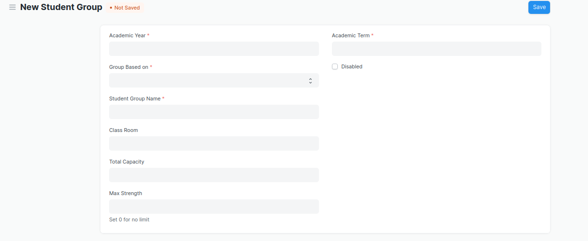
Figure 8 :Student Group screen

Field List

The following table describes the UI fields present in this screen :

ID | Field Name | Field Type | Validation/Action | Mandatory | R = Rename  N= New  D= Delete
1 | Academic Year | Link Field | Value Fetched From the Academic Year list and will show in a drop down. User will select one of them. | Yes
2 | Group Based on | Drop down | Options : Batch  Course  Activity  Mentor Communication | Yes | (D)Combined Course
3 | Student Group | Text | User will give input | Yes
4 | Max Strength | Number | User will give input
5 | Academic Term | Link Field | Link Field to Academic Term Screen and filtered applied w.r.t Academic Year
6 | Program | Link Field | Value will be fetched from Program list in a drop down.User will select one value. |  | ( R ) Course
7 | Batch | Link Field | Batch field will be visible if user select student group based upon batch
8 | Student Category | Link Field | Value will be fetched from Student Category list in drop down. User will select one value.
9 | Course | Link Field | Value will be fetched from course list , and course field will be visible when a user select group based on courses. |  | ( R ) Module
10 | Disabled | Check box | If Checked, the student group record will not be able to visible in any respective transaction
11 | Get Students | Button | User will click the Get Students Button.  2. On click list of students with respect to the course will auto fetched in the students table
12 | Students | Table | On clicking Get students button, all the students will be fetched according to the inputted parameters. And the description of the table is given below.
13 | Instructors | Table | - Instructor list need to be selected according to the inputted parameters .  - when student group based on course selected then only those instructor list will be on drop down w.r.t. the entered course.  - Description of the table is given below. |  | ( R )Trainer

Student Group Student
ID | Field Name | Field Type | Validation/Action | Mandatory
1 | Student | Link Field | Those students will come who are belongs to the particular course, semester and In group based up on activity and mentor communication, user needs to manually entered the students. | Yes
2 | Student Name | Text | Student Name will auto fetched when student Id fetched in student Field
3 | Group Roll Number | Number | Roll will auto create
4 | Active | Check box | If unchecked then this Student will not visible in any transaction

Student Group Instructor
ID | Field Name | Field Type | Validation/Action | Mandatory | R/N/M
1 | Instructors | Link Field | Value will fetch from Instructor list.User will select value. | Yes | ( R ) Trainer
2 | Instructor Name | Read only | After selecting the instructor id , this value will be auto filled. |  | ( R ) Trainer Name
3 | Course | Link Field | If course wise group created, then those course will come whose name selected in the above course field | Yes | ( R ) Module

Users: Roles and Permissions

The following table describes the users and their roles and permissions for the screens :

ID | Role | Select | Read | Write | Create | Delete | Submit | Cancel | Amend
1 | ToT coordinator/director | Yes | Yes | Yes | Yes | Yes | NA | NA | NA
2 | ToT coordinator/administrator | Yes | Yes | Yes | Yes | No | NA | NA | NA
3 | ToT assistant coordinator/trainer | No | Yes | No | No | No | NA | NA | NA

1.8 Program Enrollment

General Description

The following table describes overall information about this screen:
Description | - Program Enrollment is the record of enrollment of a student in a given program and chosen courses for a particular Academic Term.  - To ensure that students are associated with a particular program in the system, their Program Enrollment must be created. The mandatory course in that program is automatically filled in the Enrolled Courses table while the elective or optional courses can be selected manually.  - If the student has applied online for the admission in a particular Program and the application is approved, then the Program Enrollment can be created from within the Student Applicant record via clicking on the Enroll button.
Navigation | Home > Education > Admission > Program Enrollment
Pre-requisites | Student  Fee Structure  Student Batch
Existing Screen Name | Program Enrollment
New Screen Name | Course Enrollment

Screenshot
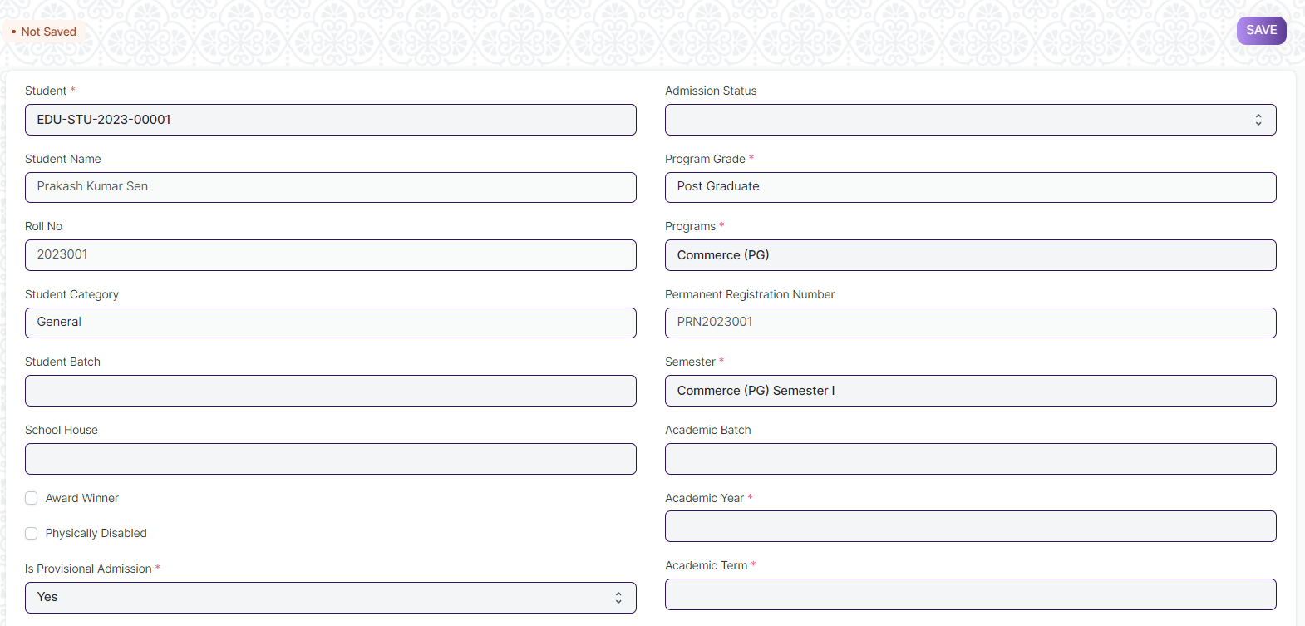
Figure 9 : Program Enrollment Screen

Field List

The following table describes the UI fields present in this screen :

ID | Label | Type | Mandatory | Validation / Action | R= Rename  N= New  D= Delete
1 | Student | Link Field | Yes | Link Fields to master screen Student, auto fetched when clicked enrolled button from student or student Applicant screen.
2 | Student Name | Read Only |  | Auto fetched when student id is inputted.
3 | Roll No | Text
4 | Gender | Link Field |  | Link Fields to master screen Gender, auto fetched when clicked enrolled connection button from student screen or enroll button from student applicant screen.
5 | Student Category | Link Field |  | Link Fields to master screen Student Category, auto fetched when clicked enrolled connection button from student screen or enroll button from student applicant screen
6 | Student Batch | Link Field |  | Link Fields to master screen Student Batch Name
7 | School House | Link Field |  | Link Fields to master screen School House
10 | Physically Disabled | Checkbox
12 | Is Provisional Admission | Dropdown | Yes | Yes  No
14 | Admission Status | Dropdown |  | Provisional Admission  Admitted
16 | Program Grade | Link Field |  | Link Fields to master screen Program Grade | ( R ) Course Grade
17 | Programs | Link Field |  | Link Fields to master screen Programs and filtered on the basis of program grade | ( R ) Courses
18 | Permanent Registration Number | Text
19 | Program | Link Field | Yes | Link Fields to master screen Semester and filtered on the basis of programs | ( R ) Semester
20 | Academic Batch | Text |  |  | (D)
21 | Academic Year | Link Field | Yes | Link Fields to master screen Academic Year auto fetched when clicked enrolled connection button from student screen. And enroll button form student applicant screen.
22 | Academic Term | Link Field |  | Link Fields to master screen Academic Term
23 | Year End Date | Date
24 | Enrollment Date | Date | Yes
25 | Seat Reservation Type | Link Field |  | Link Fields to master screen Seat Reservation Type and fetched on the basis student category wise seat reservation
26 | Available seats | Number |  | Auto fetched from Student admission screen child table Reservation distribution table.
27 | Boarding Student | Checkbox
Enrolled courses
29 | Courses | Table |  | Description of the table is given below | ( R ) Modules
Transportation
31 | Mode of Transportation
32 | Vehicle/Bus Number
34 | Due Date | Date
35 | Fee Structure Item | Table |  | - Once program enrollment record submitted for a particular student then in back-end the fees record for that particular student will created and then the student need to pay their fees from the Fees screen.  2. Description of this table is given below.
37 | Image | Attach Image |  | - On attachment a dialogue box will be popup where user can attach the images, take the picture with the help camera.  - If photos or images attached then the size will be maximum 200 kb.
38 | Academic Calendar | Table |  | Description of this table is given below.
42 | Voucher No. | Data
43 | Company | Data
44 | Submit |  |  | On submit the record the course enrollment auto created and student will be enrolled on those courses which are present in course child table

Program Enrollment Course
ID | Label | Type | Mandatory | Remarks | R= Rename  N= New  D= Delete
1 | Course | Link Field | Yes | Link Fields to master screen Course, and those courses will be visible which are linked with inputted semester | ( R ) Module
2 | Course Code | Text |  |  | ( R ) Module Code
3 | Course Name | Text |  |  | ( R ) Module Name
4 | Instructor | Link Field |  | Link Fields to master screen Instructor | ( R ) Trainer
5 | Credit Allocation | Button |  |  | ( D )

Fee Structure Item
ID | Label | Type | Mandatory | Remarks
1 | Student Category | Link Field |  | Link Fields to master screen Student Category
2 | Fee Structure | Link Field | Yes | Link Fields to master screen Fee Structure
3 | Amount | Currency
4 | Due Date | Date | Yes

Academic Calendar
ID | Label | Type | Mandatory | Remarks
1 | Academic Events | Link Field | Yes | Link Fields to master screen Academic Events, events will fetch w.r.t Academeic Calendar Template
2 | Start Date | Date | Yes | Start date will fetch w.r.t Academeic Calendar Template
3 | End Date | Date | Yes | End date will fetch w.r.t Academeic Calendar Template
4 | Duration | Number |  | Duration will fetch w.r.t Academeic Calendar Template

User: Roles & Permission

The following table describes the users and their roles and permissions for the screens :
ID | Role | Select | Read | Write | Create | Delete | Submit | Cancel | Amend
1 | ToT coordinator/director | Yes | Yes | Yes | Yes | Yes | NA | NA | NA
2 | ToT coordinator/administrator | Yes | Yes | Yes | Yes | No | NA | NA | NA
3 | ToT assistant coordinator/trainer | No | Yes | No | No | No | NA | NA | NA

1.9 Course Enrollment

General Description

The following table describes overall information about this screen:

Description | - Course Enrollment is the record of enrollment of a student in a given program and chosen courses for a particular Academic Term.  - To ensure that students are associated with a particular program in the system, their Course Enrollment must be created/auto-generated. The mandatory course in that program is automatically filled in the Enrolled Courses table while the elective or optional courses can be selected manually.  - If the student has applied online for the admission in a particular Program and the application is approved, then the Course Enrollment is auto-created from within the Program Enrollment record.
Navigation | Home > Admission > Application & Enrollment > Course Enrollment
Pre-requisites | Program Enrollment
Existing Screen Name | Course Enrollment
New Screen Name | Module Enrollment

Screenshot
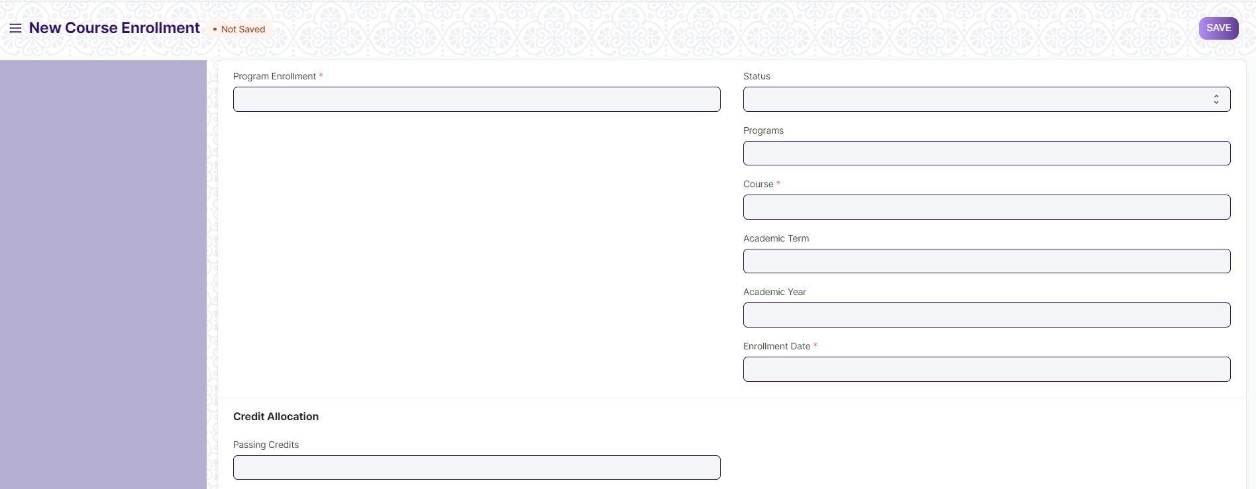
Figure 10 : Course Enrollment Screen

Field List

The following table describes the UI fields present in this screen :

ID | Label | Type | Mandatory | Remarks | R= Rename  N= New  D= Delete
1 | Program Enrollment | Link Field | Yes | Link Fields to the master screen Program Enrollment | ( R ) Course Enrollment
2 | Student | Link Field | Yes | Link Fields to the master screen Student
3 | Student Name | Text
4 | Roll No | Text
5 | Registration Number | Text
6 | Status | Dropdown
7 | Programs | Link Field |  | Link Fields to the master screen Programs | ( R ) Course
8 | Semester | Link Field |  | Link Fields to the master screen Program
9 | Course | Link Field | Yes | Link Fields to the master screen Course | ( R ) Module
10 | Course Name | Text |  |  | ( R ) Module Name
11 | Course Code | Text |  |  | ( R ) Module Code
12 | Academic Term | Link Field |  | Link Fields to the master screen Academic Term
13 | Academic Year | Link Field |  | Link Fields to the master screen Academic Year
14 | Enrollment Date | Date | Yes
15 | Credit Allocation | Label |  |  | (D)
16 | Total Credits | Float |  |  | (D)
17 | Passing Credits | Float |  |  | (D)
18 | Credit distribution | Table
19 | Grading Scale | Link Field |  | Link Fields to the master screen Grading Scale
20 | Total Course Marks | Float |  |  | ( R ) Total Module Marks
21 | Course Passing Marks | Float |  |  | ( R ) Module Passing Marks

Credit Distribution List
ID | Label | Type | Mandatory | Remarks | R= Rename  N= New  D= Delete
1 | Assessment Criteria | Link Field | Yes | Link Fields to master screen Assessment Criteria
2 | Weightage | Percent | Yes | Weightage need to be maximum 100
3 | Credits | Float | Yes |  | (D)
4 | Passing Credits | Float | Yes |  | (D)
5 | Total Marks | Float | Yes
6 | Passing Marks | Float | Yes

Topic
ID | Label | Type | Mandatory | Remarks | R= Rename  N= New  D= Delete
1 | Topic | Link Field | Yes | Link Fields to master screen Topic, and auto fetched from the course screen, w.r.t the course field data. | ( R ) Sub Module
2 | Topic Name | Text | Yes | auto fetched from the course screen, w.r.t the course field data. | ( R ) Sub Module Name
3 | Duration | Time | Yes | auto fetched from the course screen, w.r.t the course field data.
4 | Description | Long Text | Yes | auto fetched from the course screen, w.r.t the course field data. | (N)
5 | Attachment | Attach |  | - auto fetched from the course screen, w.r.t the course field data.  - On attachment a dialogue box will be popup where user can attach the files, take the picture with the help camera and can link any URL.  - If photos or images attached then the size will be maximum 200 kb.

User: Roles & Permission

The following table describes the users and their roles and permissions for the screens :

ID | Role | Select | Read | Write | Create | Delete | Submit | Cancel | Amend
1 | ToT coordinator/director | Yes | Yes | Yes | Yes | Yes | NA | NA | NA
2 | ToT coordinator/administrator | Yes | Yes | Yes | Yes | No | NA | NA | NA
3 | ToT assistant coordinator/trainer | No | Yes | No | No | No | NA | NA | NA

1.10 Instructor

General Description

The following table describes overall information about this screen:

Description | - An instructor is a teacher, tutor, or a professor who will be responsible for teaching a particular topic or course to the students.  - This screen will be used to maintain the Instructor Log in the form of a list of topics/courses covered by the Instructor. This log will have the entire history of the courses taught by the Instructor.
Navigation | Home > Admission > Student & Instructor > Instructor
Pre-requisites | - User  - Employee  - Department  - Programs  - Semester  - Course  - Academic Year  - Academic Term

Screenshot

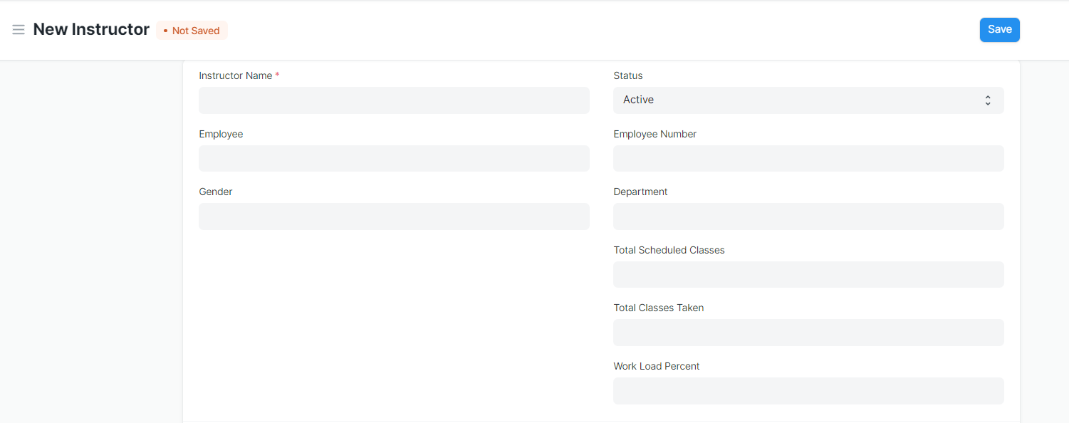
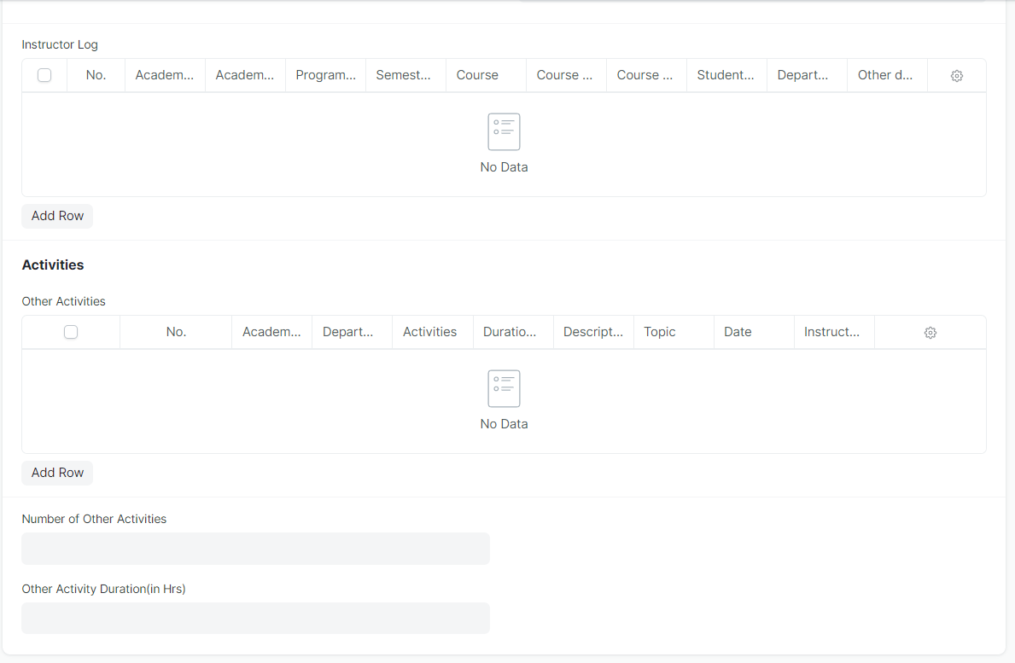
Figure 11 : Instructor Screen

Field List

The following table describes the UI fields present in this screen :

ID | Label | Type | Mandatory | Remarks | R = Rename  N= New  D= Delete
1 | Instructor Name | Text | Yes | Auto fetch the detail when employee id entered | ( R ) Trainer Name
2 | Employee | Link Field |  | Linked to Employee Screen
3 | Gender | Link Field |  | Auto fetch the detail when employee id entered
4 | Status | Dropdown
5 | Naming Series | Dropdown
6 | Employee Number | Text |  | Auto fetch the detail when employee id entered
7 | Department | Link Field |  | Auto fetch the detail when employee id entered
8 | Total Scheduled Classes | Number
9 | Total Classes Taken | Number
10 | Work Load Percent | Float
11 | Image | Attach Image |  | - On attachment a dialogue box will be popup where user can attach the image, take the picture with the help camera and can link any URL.  - If photos or images attached then the size will be maximum 200 kb.
Instructor Log
12 | Academic Year | Link Field | Yes
13 | Academic Term | Link Field |  | Academic Term is filtered on the basis of Academic Year
14 | Department | Link Field
15 | Programs | Link Field | Yes |  | ( R ) Course
16 | Semester | Link Field | Yes | Semester is filtered on the basis of Programs
17 | Course | Link Field |  | Course is filtered on the basis of semester | ( R ) Module
18 | Course code | Link Field |  | Auto fetch the detail when course entered | ( R ) Module Code
19 | Course Name | Text |  | Auto fetch the detail when course entered | ( R ) Module Name
20 | Student Group | Link Field
21 | Other details | Small Text
Activities
22 | Academic Year | Link Field |  | Linked to Academic year screen
23 | Department | Link Field |  | Linked to Department Screen
24 | Activities | Dropdown
25 | Date | Date
26 | Duration(in Hrs ) | Float
27 | Description | Long Text
28 | Topic | Text
29 | Instructor Name | Text |  |  | ( R ) Trainer Name

Users: Roles & Permission

The following table describes the users and their roles and permissions for the screens :

ID | Role | Select | Read | Write | Create | Delete | Submit | Cancel | Amend
1 | ToT coordinator/director | Yes | Yes | Yes | Yes | Yes | NA | NA | NA
2 | ToT coordinator/administrator | Yes | Yes | Yes | Yes | No | NA | NA | NA
3 | ToT assistant coordinator/trainer | No | Yes | No | No | No | NA | NA | NA

1.11 Course Schedule
General Description

The following table describes overall information about this screen:

Description | - A course schedule is a specialized functional area or a division within the Groups and schedule.  - The Course Schedule can be used for scheduling a particular course by the User.  - Using this feature, a timetable can be created for a University, wherein each slot will be scheduled via Course Schedule.
Navigation | Home > Academics > Group & Schedules > Course Schedule
Pre-requisites | 1. Student Group  2. Instructor  3. Course  4. Class  5. Classroom
Existing Screen Name | Course Schedule
New Screen Name | Module Schedule

Screenshot

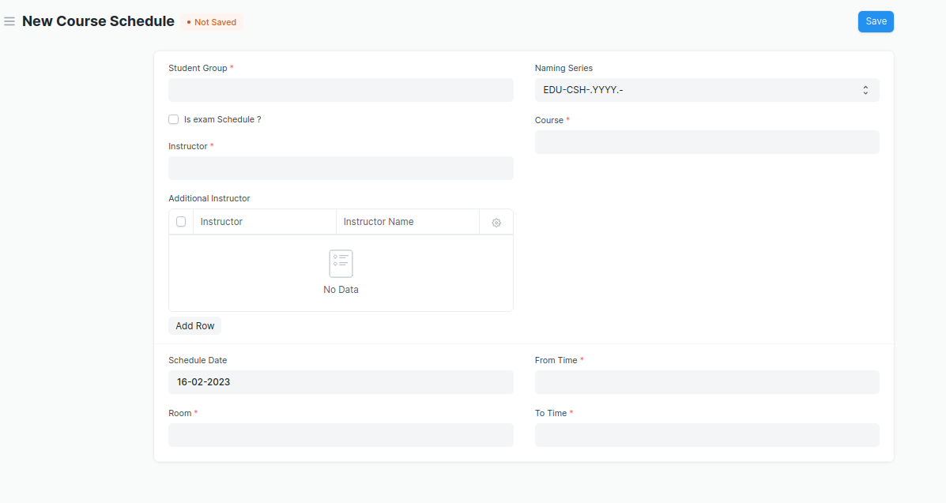
Figure 12 : Course Schedule Screen
Field List

The following table describes the UI fields present in this screen :

ID | Field Name | Field Type | Validation/Action | Mandatory | R = Rename  N= New  D= Delete
1 | Student Group | Link Field | Value will be fetched from student group list in a drop down. User will select . | Yes
2 | Instructor | Link Field | Value will be fetched from the child table (Student Group Instructor) of the selected instructor | Yes | ( R ) Trainer
3 | Instructor Name | Read only | Auto fetch instructor name from the above instruction field |  | ( R ) Trainer Name
5 | Program | Link Field | Value will be fetched from the selected student group. |  | ( R ) Course
6 | Course | Link Field | Value will be fetched from selected student group. | Yes | ( R ) Module
7 | Schedule Date | Date | User will enter the schedule date of the course
8 | Room | Link Field | Value will be fetched from the room list in a drop down . user will select. | Yes
9 | From Time | Time | User will select the time. | Yes
10 | To Time | Time | User will select the time. | Yes

**Note: Course Scheduling Tool can be used for bulk scheduling of a course. **

Users: Roles and Permissions

The following table describes the users and their roles and permissions for the screens :

ID | Role | Select | Read | Write | Create | Delete | Submit | Cancel | Amend
1 | ToT coordinator/director | Yes | Yes | Yes | Yes | Yes | NA | NA | NA
2 | ToT coordinator/administrator | Yes | Yes | Yes | Yes | No | NA | NA | NA
3 | ToT assistant coordinator/trainer | No | Yes | No | No | No | NA | NA | NA

1.12 Course Scheduling Tool

General Description

The following table describes overall information about this screen:
Description | The Course Scheduling Tool allows a user to create Course Schedules in bulk for the particular Course.
Navigation | Home > Academics > Tools > Course Scheduling Tool
Pre-requisites | 1. Student Group  2. Instructor  3. Course  4. Class  5. Classroom
Existing Screen Name | Course Scheduling Tool
New Screen Name | Module Scheduling Tool

Screenshot

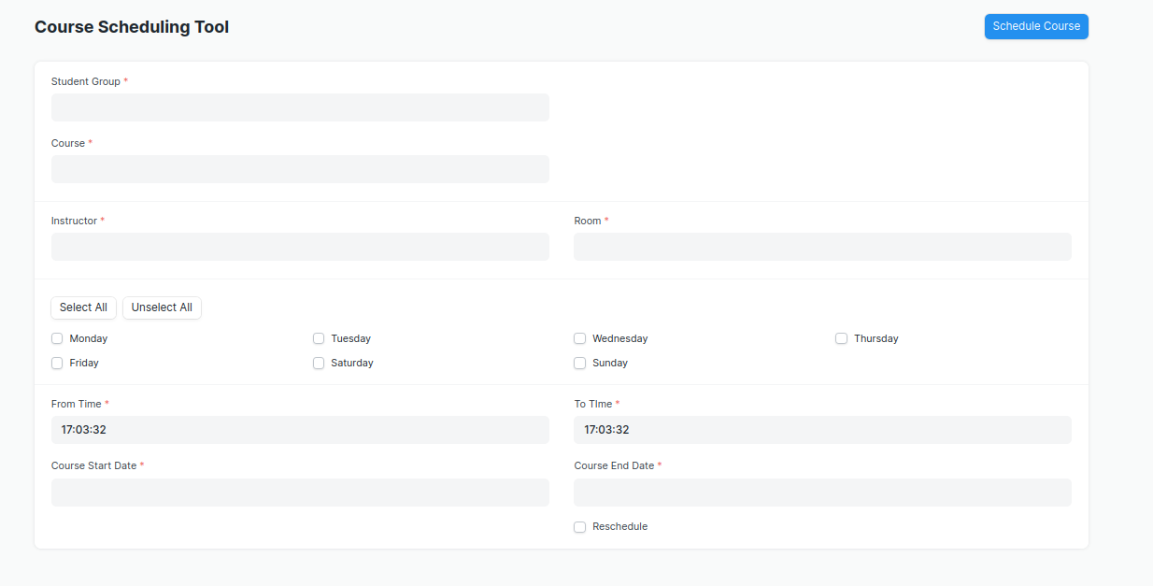
Figure 13 : Course Scheduling Tool Screen

Field List

The following table describes the UI fields present in this screen :
ID | Field Name | Field Type | Validation/Action | Mandatory | R = Rename  N= New  D= Delete
1 | Student Group | Link Field | Value will be fetched from Student Group List, User will select one of them | Yes
2 | Course | Link Field | Value will be fetched from course list.User will select one. | Yes | ( R ) Module
3 | Program | Link Field | Value will be fetched from  Program list, user will select. |  | ( R ) Course
4 | Academic Year | Link Field | Value will be fetched from  Academic year list,user  Will select one.
5 | Academic Term | Link Field | Based on the academic year,  Academic term will show in a drop down. User will select.
6 | Instructor | Link Field | Value will be fetched from  Instructor list,user will select one. | Yes | ( R ) Trainer
7 | Instructor Name | Read Only | Automatically filled up after  Selecting Instructor. |  | ( R ) Trainer Name
8 | Room | Link Field | Value will be fetched from  Room list, user will select one. | Yes
9 | From Time | Time | User will select time. | Yes
10 | Course Start Date | Date | Start date should be before the End Date | Yes | ( R ) Module Start Date
11 | To Time | Time | User will select time. | Yes
12 | Course End Date | Date | Course End date should be greater then Course Start Date | Yes | ( R ) Module End Date

- User will Click on ‘Schedule Course’ Button.

**Note: The system should create the course schedules if the classroom and Instructor are
available and there is no conflict for the selected Student Group with other course
schedules.

Rescheduling
1. User can reschedule the course schedules created.
2. User will Check the ‘Reschedule Checkbox and then click on ‘Schedule Course’.
3. System should delete the existing Course Schedules for the particular Course within the
mentioned Start Date and End Date and should create a new Course Schedules.

**The entries for all the Course Scheduling Tools should created in the Course Schedule
Document. **

Users: Roles and Permissions

The following table describes the users and their roles and permissions for the screens :

ID | Role | Select | Read | Write | Create | Delete | Submit | Cancel | Amend
1 | ToT coordinator/director | Yes | Yes | Yes | Yes | Yes | NA | NA | NA
2 | ToT coordinator/administrator | Yes | Yes | Yes | Yes | No | NA | NA | NA
3 | ToT assistant coordinator/trainer | No | Yes | No | No | No | NA | NA | NA

1.15 Student Attendance

General Description

The following table describes overall information about this screen:
Description | The Student Attendance allows you to keep track and mark the attendance of a student for a day. Attendance records can be created against students on a daily basis.
Navigation | Home > Academics > Attendance and Leave Application > Student Attendance
Pre-requisites | 1. Student  2. Course Schedule  3. Student Group

Screenshot

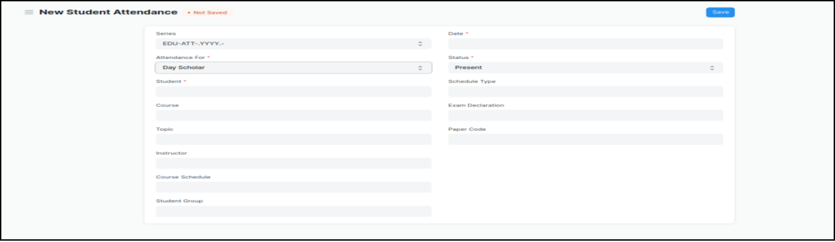
Figure 14 : Student Attendance Screen

Field List:

The following table describes the UI fields present in this screen :

ID | Field Name | Field Type | Validation/Action | Mandatory | R = Rename  N= New  D= Delete
1 | Student | Link Field | Value will be fetched from Student list,user will select . | Yes
2 | Student Name | Read only | After selecting student id, this field will be  Automatically filled up.
3 | Course Schedule | Link Field | Value will be fetched from course schedule list. |  | - Module Schedule
4 | Student Group | Link Field | Value will be fetched from Student group list in which the student is present.
5 | Date | Date | User will select the current date | Yes
6 | Status | Dropdown | Options : Present, Absent,  User will select . | Yes
7 | Course | Link Field | Value will be fetched from Course list that the student have enrolled.User will select |  | ( R ) Module

**Note: The Attendance can be marked for the Exams and also the Student Attendance Tool can be used for bulk upgradation of the attendance.

Users: Roles and Permissions

The following table describes the users and their roles and permissions for the screens :
ID | Role | Select | Read | Write | Create | Delete | Submit | Cancel | Amend
1 | ToT coordinator/director | Yes | Yes | Yes | Yes | Yes | NA | NA | NA
2 | ToT coordinator/administrator | Yes | Yes | Yes | Yes | No | NA | NA | NA
3 | ToT assistant coordinator/trainer | No | Yes | No | No | No | NA | NA | NA

1.16 Student Attendance Tool

General Description

The following table describe overall information about this screen:
Description | The Student Attendance Tool allows user to bulk update the Attendance for Students based on Student Group and Course Schedule.
Navigation | Home > Academics > Tools > Student Attendance Tool
Pre-requisites | 1. Student  2. Course Schedule  3. Student Group

Screenshot

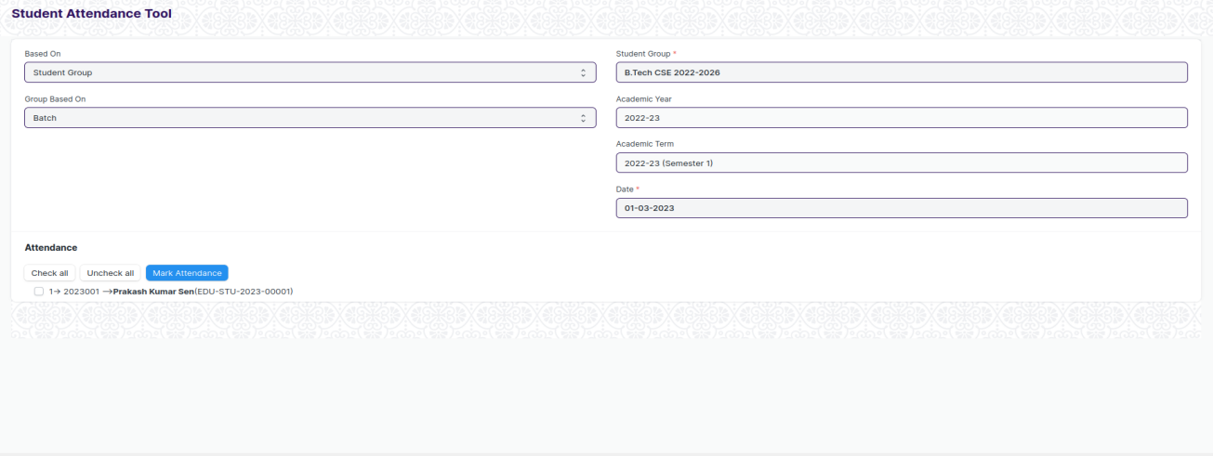
Figure 15 : Student Attendance Screen
Field List

The following table describes the UI fields present in this screen :
ID | Field Name | Field Type | Validation/Action | Mandatory | R = Rename  N= New  D= Delete
1 | Based On | Dropdown | Options : Student Group  Course Schedule
2 | Group Based On | Dropdown | Options :Batch  Course  Activity
3 | Student Group | Link Field | Value will be fetched from  Student group list.User  Will select one. | Yes
4 | Academic Year | Link Field | Value will be fetched from  Academic year,user will  Select one.
5 | Academic Term | Link Field | Value will be fetched  Based on selected academic year.
6 | Course Schedule | Link Field | Value will be fetched based on course schedule list. |  | ( R ) Module Schedule
7 | Date | Date | User will select the date, Date should not be the future date | Yes

Users: Roles and Permissions

The following table describes the users and their roles and permissions for the screens :

ID | Role | Select | Read | Write | Create | Delete | Submit | Cancel | Amend
1 | ToT coordinator/director | Yes | Yes | Yes | Yes | Yes | NA | NA | NA
2 | ToT coordinator/administrator | Yes | Yes | Yes | Yes | No | NA | NA | NA
3 | ToT assistant coordinator/trainer | No | Yes | No | No | No | NA | NA | NA

1.17 Assignment

General Description

The following table describes overall information about this screen:

Description | In Assignment Screen Trainers can easily provide assignment to their respective students, so that it gives a strong bonding between the students and the trainers.
Navigation
Pre-requisites | - Instructor  - Student Group

Screenshot

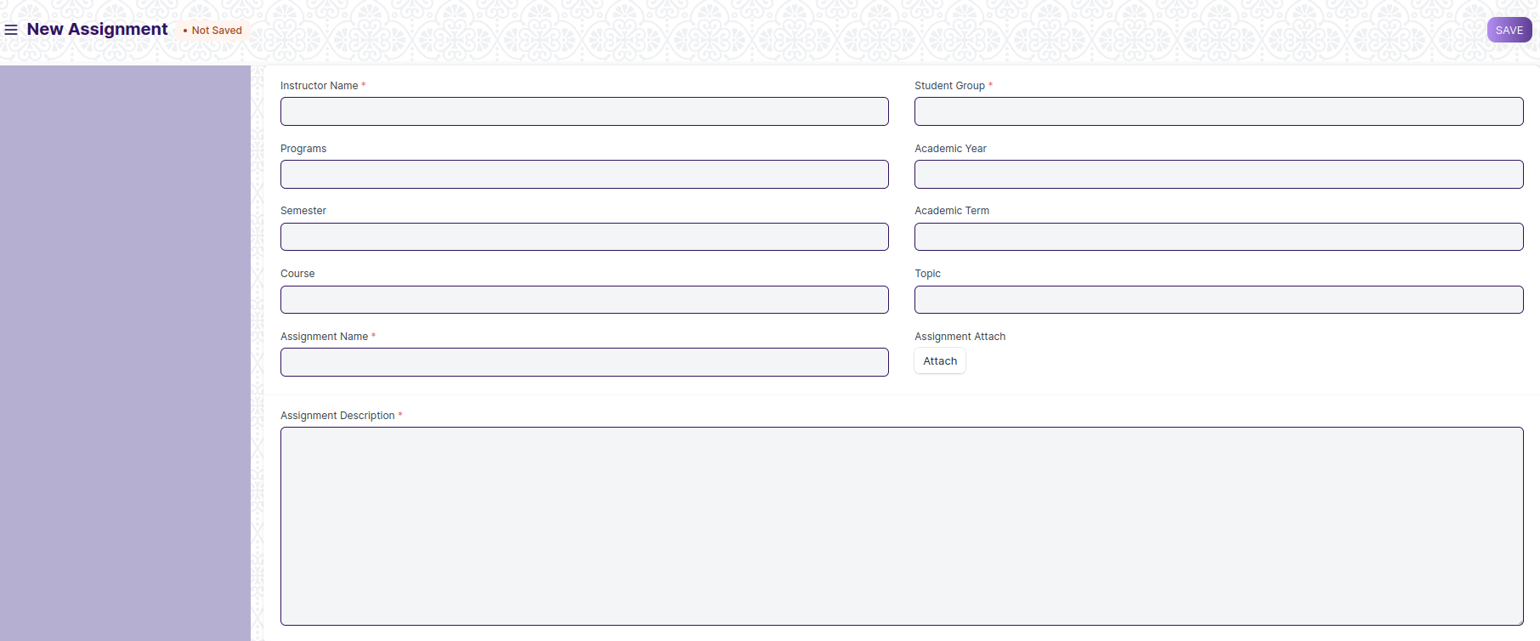
Figure 16 : Assignment Screen

Field List

The following table describes the UI fields present in this screen :

ID | Field Name | Field Type | Validation/Action | Mandatory | R = Rename  N= New  D= Delete
1 | Instructor Name | Link Field | Links with Instructor Screen, filters w.r.t Student Group | Yes
2 | Student Group | Link Field | Links with Student Group Screen | Yes
3 | Programs | Link Field | It will auto fetch when Student Group is entered, filters w.r.t Student Group |  | ( R ) Course
4 | Semester | Link Field | It will auto fetch when Student Group is entered, filters w.r.t Student Group
5 | Course | Link Field | It will auto fetch when Student Group is entered, filters w.r.t Student Group |  | ( R ) Module
6 | Topic | Link Field | Links with Topic Screen and filters topics should come with respect to the above course field |  | (R) Sub Module
7 | Assignment Name | Text | User Input | Yes
8 | Assignment Attach Button | Attach | - On attachment a dialogue box will be popup where user can attach the files, images , takes the picture with the help camera and can link any URL.  If photos or images attached then the size will be maximum 200 kb.
9 | Description | Long Text |  | Yes
 | Submit |  | On Submit the assignment will be able to visible only to their respective students.

Users: Roles and Permissions

The following table describes the users and their roles and permissions for the screens :

ID | Role | Select | Read | Write | Create | Delete | Submit | Cancel | Amend
1 | ToT coordinator/director | Yes | Yes | Yes | Yes | Yes | NA | NA | NA
2 | ToT coordinator/administrator | Yes | Yes | Yes | Yes | No | NA | NA | NA
3 | ToT assistant coordinator/trainer | No | Yes | No | No | No | NA | NA | NA

1.18 Assignment Upload

General Description

The following table describes overall information about this screen:

Description | In Assignment Upload Screen Students can easily upload their assignment and it will securely go to their respective trainers.
Navigation
Pre-requisites | - Student Group  - Assignment

Screenshot

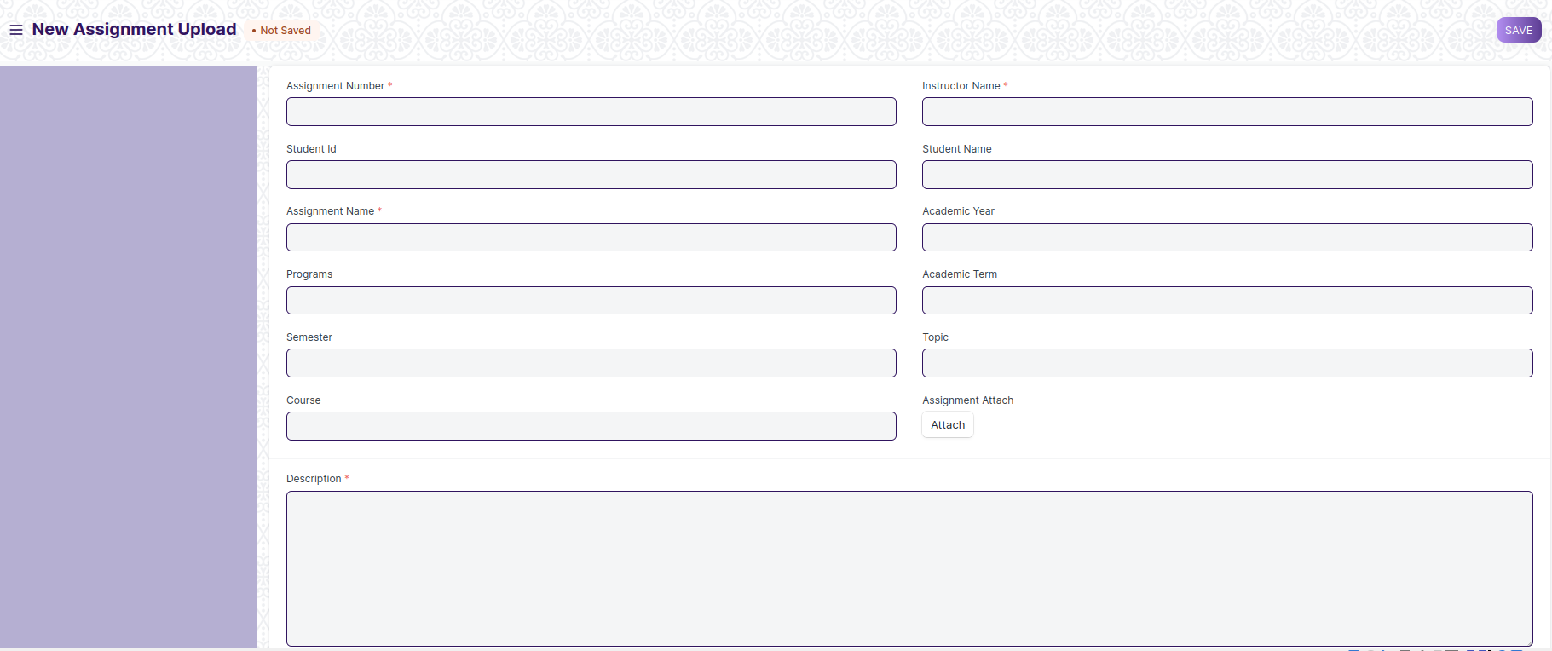
Figure 17: Assignment Upload

Field Type

The following table describes the UI fields present in this screen :

ID | Field Name | Field Type | Validation/Action | Mandatory | R = Rename  N= New  D= Delete
1 | Instructor Name | Link Field | Links with Instructor Screen | Yes
2 | Assginment Number | Link Field | Links with Assignment Screen | Yes
3 | Student Id | Link Field | Link with Student Screen
4 | Student name | Text Field | It will auto fetch when Student Id is entered
5 | Programs | Link Field | It will auto fetch when Student Id is entered |  | ( R ) Course
6 | Semester | Link Field | It will auto fetch when Student Id is entered
7 | Academic Year | Link Field | Link with Academic Year Screen
8 | Academic Term | Link Field | Link with Academic Term and Value will be fetched based on selected Academic year.
9 | Course | Link Field | It will auto fetch when Student Id is entered |  | ( R ) Module
10 | Topic | Link Field | Links with Topic Screen and filters topics should come with respect to the course |  | (R) Sub Module
11 | Assignment Name | Text | User Entered | Yes
12 | Assignment Attach Button | Attach | - On attachment a dialogue box will be popup where user can attach the image, take the picture with the help camera and can link any URL.  - If photos or images attached then the size will be maximum 200 kb.
13 | Description | Long Text |  | Yes
 | Submit |  | On Submit assignment will be shown only to that particular instructor.

Users: Roles and Permissions

The following table describes the users and their roles and permissions for the screens :

ID | Role | Select | Read | Write | Create | Delete | Submit | Cancel | Amend
1 | ToT coordinator/director | Yes | Yes | Yes | Yes | Yes | NA | NA | NA
2 | ToT coordinator/administrator | Yes | Yes | Yes | Yes | No | NA | NA | NA
3 | ToT assistant coordinator/trainer | No | Yes | No | No | No | NA | NA | NA

1.19 Exam Declaration
General Description
Description | The Exam Declaration will allow user to declare an exam for various programs in accordance with the ‘Academic Calendar’ template which was used during the start of each session.
Navigation | Home > Examination > Examination>Exam Declaration
Pre-requisites | - Academic Calendar  - Program  - Academic Year
Existing Screen Name | Exam Declaration
New Screen Name | NA

Screenshot

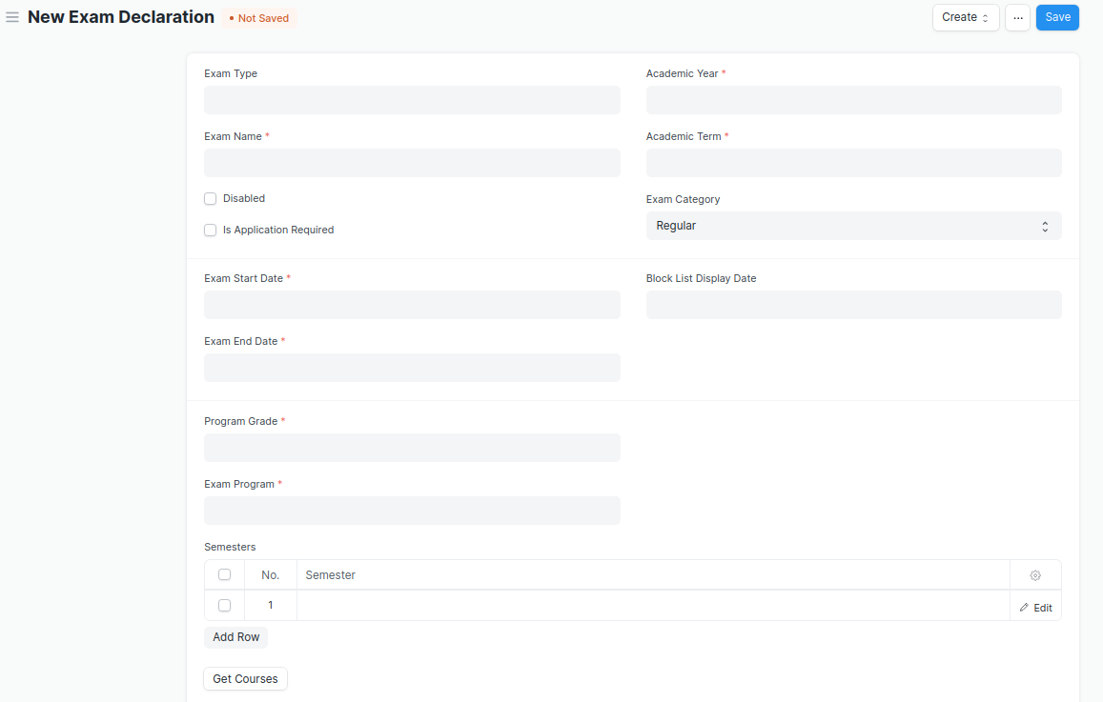
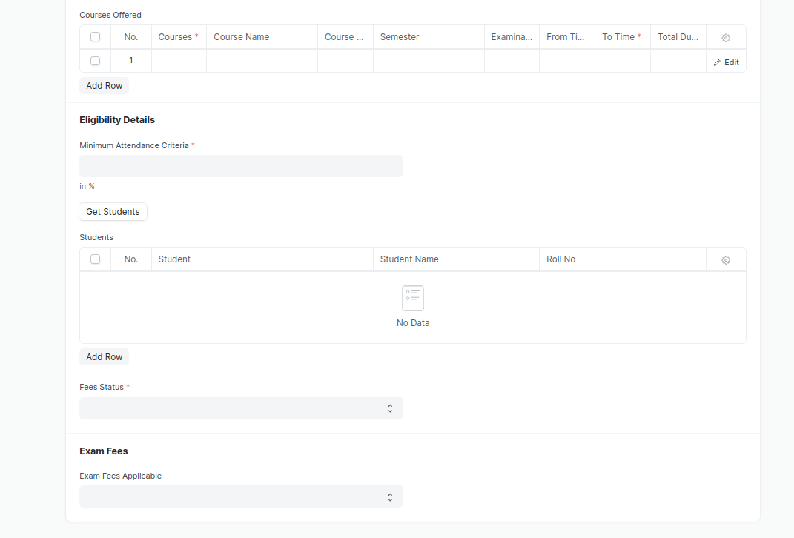
Figure 18 : Exam Declaration

- A notification or mail will be sent directly to the student after the exam declaration are announced.
- A field is required for exam Declaration to show which room and seat number will be used.
- There should be a provision in the exam declaration form for assigning an invigilator, a marker, and a checker for each module.

Field List

The “Exam Declaration” screen shall consist of the following fields:

ID | Field Label | Field Type | Validation/Action | Mandatory | Remarks | R/N/D
1 | Exam Type | Link Field | Fetched from Exam Type master screen
2 | Exam Name | Text Field | User Input | Y
3 | Disabled | Checkbox | User Input
4 | Is Application Required | Checkbox | User Input
5 | Academic Year | Link Field | Fetched from Academic Year master screen | Y
6 | Academic Term | Link Field | Fetched from Academic Term master screen | Y
7 | Exam Category | Drop down | Regular/Re-Exam
8 | Application Form Start Date | Date Picker | Display and Mandatory if “Is Application Required” is checked
9 | Application Form End Date | Date Picker | - Display and Mandatory if “Is Application Required” is checked  - Should be greater than Start Date
10 | Exam Start Date | Date Picker | User Input | Y
11 | Exam End Date | Date Picker | Should be greater than Start Date | Y
12 | Admit Card Issue Date | Date Picker | User Input
13 | Block List Display Date | Date Picker | Date should be before “Exam Start Date”
14 | Program Grade | Link | Fetched from Program Grades master screen | Y |  | - Course Grade
15 | Exam Program | Link | Program will be fetched based from selected “Program Grade” | Y |  | (R) Exam Course
16 | Semesters | Table | Child table: Examination Semester | Y | These table is describe below
17 | Get Courses | Button | Courses will be fetched based on Selected “Exam Program” and “Semester” |  |  | (R) Get Modules
18 | Courses Offered | Table | Child table: Exam Courses | Y | These table is describe below | (R) Modules Offered
19 | Minimum Attendance Criteria | Float | User Input | Y
20 | Get Students | Button | Students will be fetched based on selected “Exam Program”,”Semester”,”Academic Year”,”Academic Term”
21 | Total Enrolled Student | Number | Calculated total number of Students fetched based on “Get Students” Button
22 | Students | Table | Child table: Students |  | These table is describe below
23 | Fees Status | Drop down | Full Paid/  More than 50%/  Allow all | Y
24 | Exam Fees Applicable | Drop down | YES/NO
25 | Fee Structure | Table | If “Exam Fees Applicable” is “Yes” then table will show |  | These table is describe below

Semesters
ID | Field Label | Field Type | Validation/Action | Mandatory | Remarks | R/N/D
1 | Semester | Link Field | Fetched from Semester master screen and filtered based on Selected “Exam Program” | Y

 | Courses Offered
ID | Field Label | Field Type | Validation/Action | Mandatory | Remarks | R/N/D
1 | Courses | Link Field | Auto fetch based on “Get Courses” Button | Y |  | (R) Modules
2 | Course Name | Text field | Auto fetch based on “Get Courses” Button |  |  | (R) Modules Name
3 | Course Code | Text field | Auto fetch based on “Get Courses” Button |  |  | (R) Modules Code
4 | Semester | Link Field | Auto fetch based on “Get Courses” Button
5 | Examination Date | Date Picker | User Input | Y
6 | From Time | Time | User Input | Y
7 | To Time | Time | User Input | Y
8 | Total Duration (in Hours) | Time | Calculated based on “From Time” & “To Time”

Students
ID | Field Label | Field Type | Validation/Action | Mandatory | Remarks | R/N/D
1 | Student | Text Field | Auto fetch based on “Get student” Button
2 | Student Name | Text Field | Auto fetch based on “Get student” Button
3 | Roll No | Text Field | Auto fetch based on “Get student” Button
4 | Registration Number | Text Field | Auto fetch based on “Get student” Button

Fee Structure
ID | Field Label | Field Type | Validation/Action | Mandatory | Remarks | R/N/D
1 | Student Category | Link Field | Fetched from Student Category master screen | Y
2 | Fee Structure | Link Field | Fetched from Fee Structure master screen
3 | Amount | Currency Field | Auto fetch based on “Fee Structure”
4 | Due Date | Date Picker |  | Y

Exam Attendance Sheet Print Format
General Description
Description | On Click of Print button in Exam Declaration Screen a print format will be generated, it can also be converted into PDF format.
Navigation
Pre-requisites | Exam Declaration
Existing Screen Name
New Screen Name

Exam Attendance Sheet Print Format Screenshot
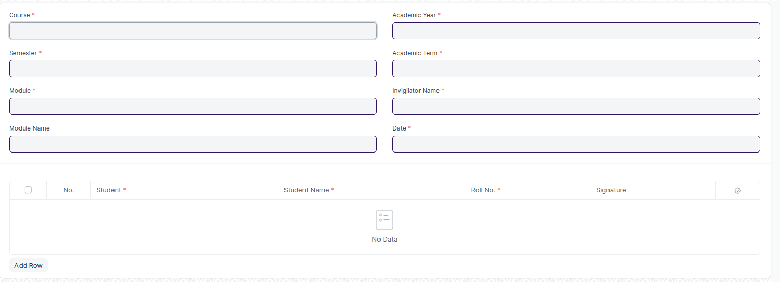
Figure 19 : Exam Attendance Sheet Print Format

Exam Attendance Sheet Print Format Field List

The “Exam Attendance Sheet Print Format” screen shall consist of the following fields:

ID | Field Label | Field Type | Validation/Action | Mandatory | Remarks | R/N/D
1 | Course | Link Field | Auto fetch based on “Exam Declaration” | Y |  | N
2 | Semester | Text Field | Auto fetch based on “Exam Declaration” |  |  | N
3 | Module | Link Field | Auto fetch based on “Exam Declaration” | Y |  | N
4 | Module Name | Text Field | Auto fetch based on “Exam Declaration” |  |  | N
5 | Academic Year | Link Field | Auto fetch based on “Exam Declaration” |  |  | N
6 | Academic Term | Link Field | Auto fetch based on “Exam Declaration” |  |  | N
7 | Trainer Name | Text Field | Auto fetch based on “Exam Declaration” | Y |  | N
8 | Students | Table | Auto fetch based on “Exam Declaration” |  |  | N

Students
ID | Field Label | Field Type | Validation/Action | Mandatory | Remarks | R/N/D
1 | Student | Text Field | Auto fetch based on “Exam Declaration”
2 | Student Name | Text Field | Auto fetch based on “Exam Declaration”
3 | Roll No | Text Field | Auto fetch based on “Exam Declaration”
4 | Registration Number | Text Field | Auto fetch based on “Exam Declaration”

Exam Score Sheet Print Format
General Description
Description | On Click of Print button in Exam Declaration Screen a print format will be generated, it can also be converted into PDF format.
Navigation
Pre-requisites | Exam Declaration
Existing Screen Name
New Screen Name

Exam Score Sheet Print Format Screenshot

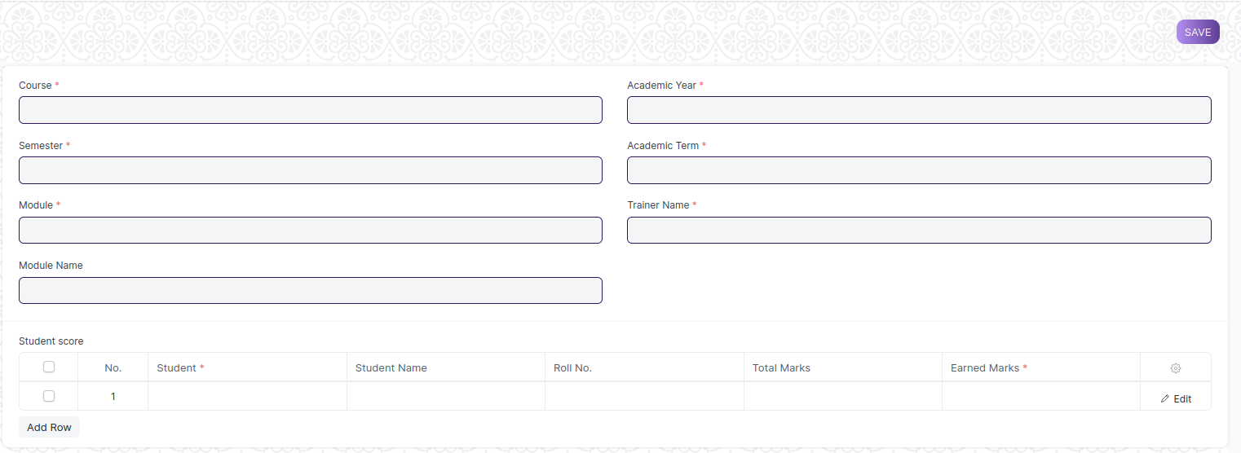
Figure 20 : Exam Score Sheet Print Format

Exam Score Sheet Print Format Field List

The “Exam Score Sheet Print Format” screen shall consist of the following fields:

ID | Field Label | Field Type | Validation/Action | Mandatory | Remarks | R/N/D
1 | Course | Link Field | Auto fetch based on “Exam Declaration” | Y |  | N
2 | Semester | Link Field | Auto fetch based on “Exam Declaration” | Y |  | N
3 | Module | Link Field | Auto fetch based on “Exam Declaration” | Y |  | N
4 | Module Name | Text Field | Auto fetch based on “Exam Declaration” |  |  | N
5 | Academic Year | Link Field | Auto fetch based on “Exam Declaration” |  |  | N
6 | Academic Term | Link Field | Auto fetch based on “Exam Declaration” |  |  | N
7 | Invigilator Name | Text Field | Auto fetch based on “Exam Declaration” | Y |  | N
8 | Date | Date Picker | Auto fetch based on “Exam Declaration” |  |  | N
9 | Students | Table | Auto fetch based on “Exam Declaration” |  |  | N

Students
ID | Field Label | Field Type | Validation/Action | Mandatory | Remarks | R/N/D
1 | Student | Text Field | Auto fetch based on “Exam Declaration”
2 | Student Name | Text Field | Auto fetch based on “Exam Declaration”
3 | Roll No | Text Field | Auto fetch based on “Exam Declaration”
4 | Registration Number | Text Field | Auto fetch based on “Exam Declaration”
5 | Earned Marks | Number | User Input
6 | Total Marks | Number | User Input

User: Roles & Permission

The following table describes the users and their roles and permissions for the screens :

ID | Role | Select | Read | Write | Create | Delete | Submit | Cancel | Amend
1 | ToT coordinator/director | Yes | Yes | Yes | Yes | Yes | NA | NA | NA
2 | ToT coordinator/administrator | Yes | Yes | Yes | Yes | No | NA | NA | NA
3 | ToT assistant coordinator/trainer | No | Yes | No | No | No | NA | NA | NA

1.20 Exam Evaluation Plan
General Description
Description | An Exam Evaluation Plan is a schedule to conduct the examination/assessment of a particular course for a group of students studying that course in an on-going academic term.
Navigation | Home > Examination > Evaluation > Exam Evaluation Plan
Pre-requisites | - Exam Declaration  - Instructor & Instructor Log  - Program  - Semester  - Course  - Student Group
Existing Screen Name | Exam Evaluation Plan
New Screen Name | NA

Screenshot

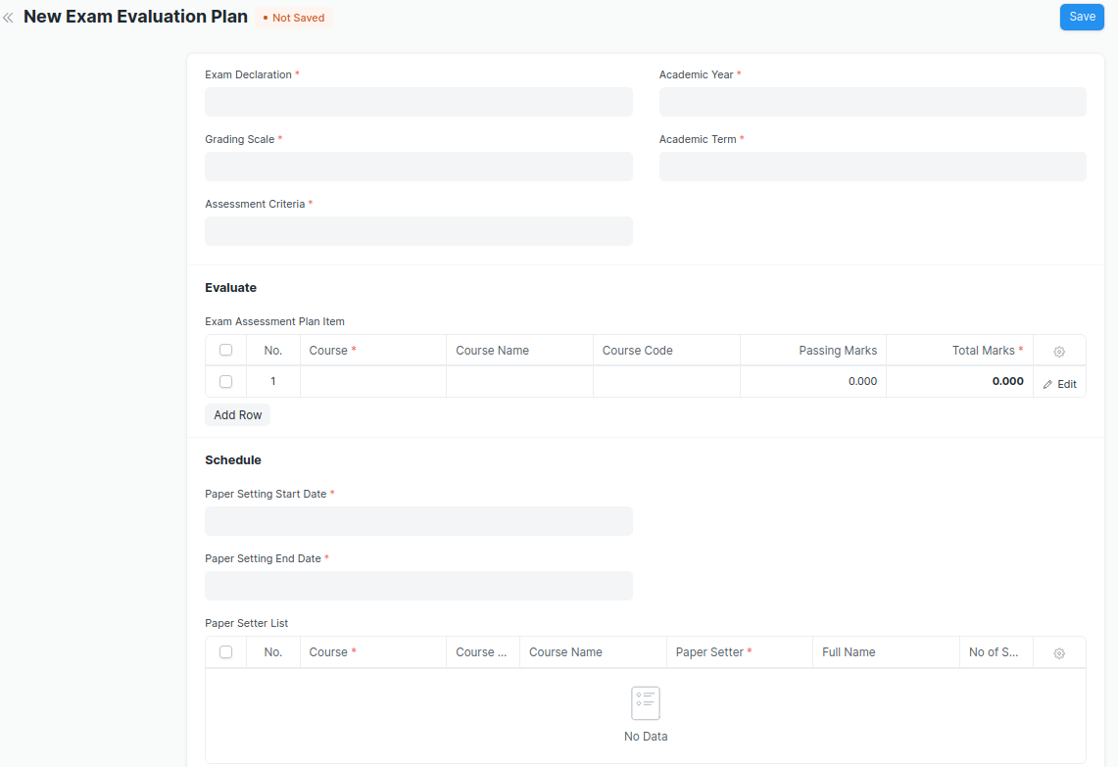
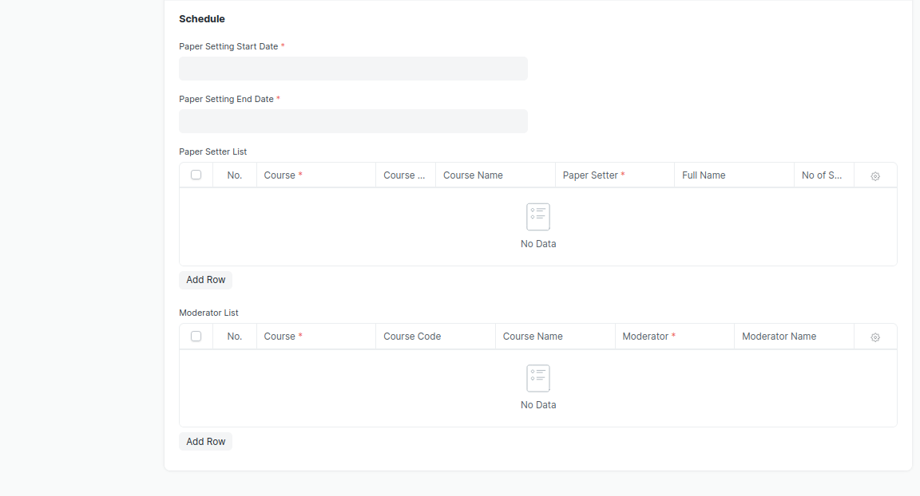
Figure 21 : Exam Evaluation Plan Screen

Field List

The “Exam Evaluation Plan” screen shall consist of the following fields:

ID | Field Label | Field Type | Validation/Action | Mandatory | Remarks | R/N/D
1 | Exam Declaration | Link Field | Fetched from Exam Declaration master screen | Y
2 | Grading Scale | Link Field | Fetched from Grading Scale master screen | Y
3 | Assessment Criteria | Link Field | Fetched from Assessment Criteria master screen | Y
4 | Programs | Link Field | Auto fetch based on “Exam Declaration” | Y |  | (R) Course
5 | Semester | Link Field | Filtered will be applied based on selected “Programs” and existing “Exam Declaration” | Y
6 | Academic Year | Link Field | Auto fetch based on “Exam Declaration” | Y
7 | Academic Term | Link Field | Auto fetch based on “Exam Declaration” | Y
8 | Exam Assessment Plan Item | Table | Child Table: Course Assessment Plan Item | Y | These table is describe below
9 | Paper Setting Start Date | Date Picker | User Input | Y
10 | Paper Setting End Date | Date Picker | User Input | Y
11 | Paper Setter List | Table | Child Table: Moderator List |  | These table is describe below
12 | Moderator List | Table | Child Table: Exam Assessment Plan |  | These table is describe below

Exam Assessment Plan Item
ID | Field Label | Field Type | Validation/Action | Mandatory | Remarks | R/N/D
1 | Course | Link Field | Auto fetch based on selected “Programs” & “Semester” & “Assessment Criteria” | Y |  | (R) Module
2 | Course Name | Text Field | Auto fetch based on Course |  |  | (R) Module Name
3 | Course Code | Text Field | Auto fetch based on Course |  |  | (R) Module Code
4 | Passing Marks | Number | Auto fetch based on Course
5 | Total Marks | Number | Auto fetch based on Course | Y
6 | Total Credit | Number | Auto fetch based on Course | Y

Paper Setter List
ID | Field Label | Field Type | Validation/Action | Mandatory | Remarks | R/N/D
1 | Course | Link Field | Only fetch those courses which belongs to the selected semester | Y |  | (R) Module
2 | Course Code | Text Field | Auto fetch based on Course |  |  | (R) Module Code
3 | Course Name | Text Field | Auto fetch based on Course |  |  | (R) Module Name
4 | Paper Setter | Link Field | Fetched from Instructor master screen | Y
5 | Full Name | Text Field | Auto fetch based on Paper Setter
6 | No of Sets | Number |  | Y

Moderator List
ID | Field Label | Field Type | Validation/Action | Mandatory | Remarks | R/N/D
1 | Course | Link Field | Fetched those course which are present in Paper setter list | Y |  | (R) Module
2 | Course Code | Text Field | Auto fetch based on Course |  |  | (R) Module Code
3 | Course Name | Text Field | Auto fetch based on Course |  |  | (R) Module Name
4 | Moderator | Link Field | Fetched from Instructor master screen | Y
5 | Moderator Name | Text Field | Auto fetch based on Moderator

User: Roles & Permission

The following table describes the users and their roles and permissions for the screens :

ID | Role | Select | Read | Write | Create | Delete | Submit | Cancel | Amend
1 | ToT coordinator/director | Yes | Yes | Yes | Yes | Yes | NA | NA | NA
2 | ToT coordinator/administrator | Yes | Yes | Yes | Yes | No | NA | NA | NA
3 | ToT assistant coordinator/trainer | No | Yes | No | No | No | NA | NA | NA

1.21 Exam Paper Setting
General Description
Description | The Exam Paper Setting is used to prepare paper setting schedules and plan for paper setters and moderators for a particular exam declaration.
Navigation | Home > Examination > Examination> Exam Paper
Pre-requisites | Exam Evaluation Plan
Existing Screen Name | Exam Paper Settings
New Screen Name | NA

Screenshot

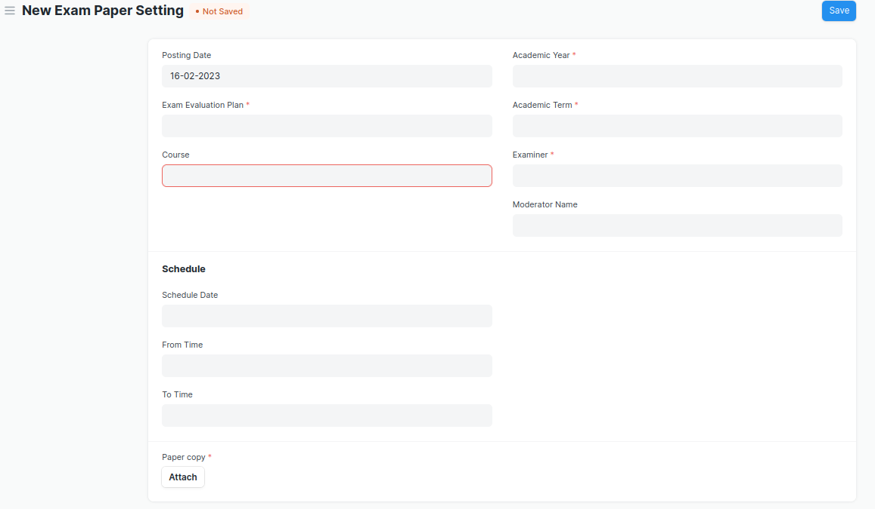
Figure 22 : Exam Paper Setting Screen

- After the paper setter moderator list is published, the paper setter will take three weeks to set the paper, and the moderator will take one week to check the paper sets.
- The paper gets reviewed by the reviewer. In case reviewer is unavailable, the paper is reviewed by Dy Director.

Field List

The “Exam Paper Setting” screen shall consist of the following fields:

ID | Field Label | Field Type | Validation/Action | Mandatory | Remarks | R/N/D
1 | Posting Date | Date | By default Today’s date is fetched
2 | Exam Evaluation Plan | Link Field | Fetched from Exam Evaluation Plan master screen | Y
3 | Programs | Link Field | Auto fetched based on “Exam Evaluation Plan” |  |  | (R) Course
4 | Semester | Link Field | Auto fetched based on “Exam Evaluation Plan”
5 | Course | Link Field | Course will be fetched based on selected “Exam Evaluation Plan” | Y |  | (R) Module
6 | Course Code | Text Field | Auto fetch based on Course |  |  | (R) Module Code
7 | Course Name | Text Field | Auto fetch based on Course |  |  | (R) Module Name
8 | Academic Year | Link Field | Auto fetched based on “Exam Evaluation Plan” | Y
9 | Academic Term | Link Field | Auto fetched based on “Exam Evaluation Plan” | Y
10 | Examiner | Link Field | Examiner will be fetched based on selected “Exam Evaluation Plan”
11 | Examiner Name | Text Field | Examiner will be fetched based on selected “Exam Evaluation Plan”
12 | Moderator Name | Link Field | Examiner will be fetched based on selected “Exam Evaluation Plan”
13 | Schedule Date | Date picker | User Input
14 | From Time | Time picker | User Input
15 | To Time | Time picker | User Input
16 | Paper copy | Attachment Button | - Attach button will only visible to that instructor whose name is provided in paper setter list.  - On attachment a dialogue box will be popup where user can attach the files, take the picture with the help camera and can link any URL.  - If photos or images attached then the size will be maximum 200 kb. | Y

User: Roles & Permission

The following table describes the users and their roles and permissions for the screens :

ID | Role | Select | Read | Write | Create | Delete | Submit | Cancel | Amend
1 | ToT coordinator/director | Yes | Yes | Yes | Yes | Yes | NA | NA | NA
2 | ToT coordinator/administrator | Yes | Yes | Yes | Yes | No | NA | NA | NA
3 | ToT assistant coordinator/trainer | No | Yes | No | No | No | NA | NA | NA

1.22 Criteria Wise Evaluation
General Description
Description | Criteria Wise Evaluation allows us to create an evaluation for a particular assessment criterion in a course for a student enrolled in that course.
Navigation | Home > Examination > Evaluation > Criteria Wise Evaluation
Pre-requisites | - Exam Declaration  - Course  - Assessment Criteria  - Grading Scale
Existing Screen Name | Criteria Wise Evaluation
New Screen Name | NA

Screenshot

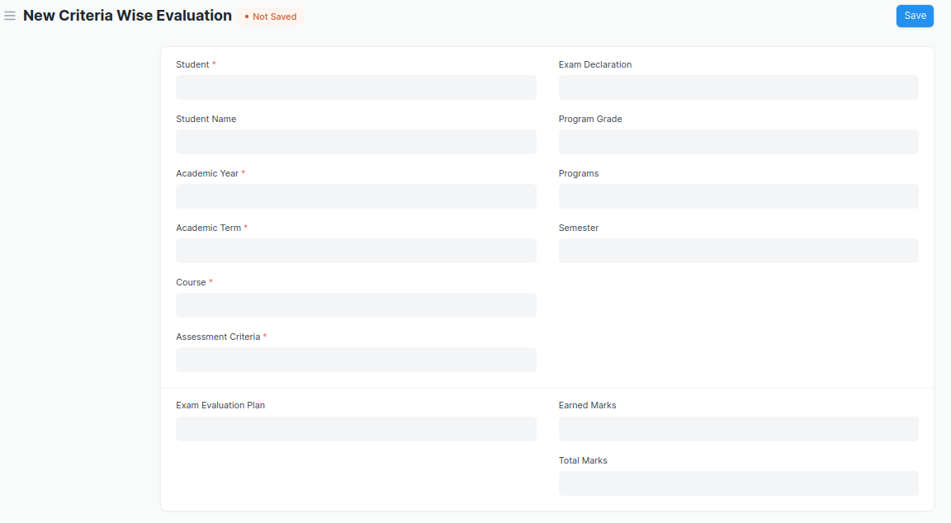
Figure 23 : Criteria Wise Evaluation Screen

- Two instructors independently evaluate a student's assessment without knowing the other's score and then come together to compare their results and determine the final grade.

Field List

The “Criteria Wise Evaluation” screen shall consist of the following fields:

ID | Field Label | Field Type | Validation/Action | Mandatory | Remarks | R/N/D
1 | Student | Link Field | Fetched from student master screen | Y
2 | Student Name | Text Field | Auto fetch based on Student
3 | Roll No | Text Field | Auto fetch based on Student
4 | Registration Number | Text Field | Auto fetch based on Student
5 | Academic Year | Link Field | Auto fetched based on selected “Exam Declaration” | Y
6 | Academic Term | Link Field | Auto fetched based on selected “Exam Declaration” | Y
7 | Course | Link Field | Fetched from Course master screen, filtered will be applied Student enrolled course | Y |  | (R) Module
8 | Course Name | Text Field | Auto fetch based on Course |  |  | (R) Module Name
9 | Assessment Criteria | Link Field | Fetched from Assessment Criteria master screen | Y
10 | Exam Declaration | Link Field | Fetched from Exam Declaration master screen
11 | Program Grade | Link Field | Fetched from Program Grades master screen |  |  | (R) Course Grade
12 | Programs | Link Field | Auto fetched based on selected “Exam Declaration” |  |  | (R) Course
13 | Semester | Link Field | Fetched from Semester master screen,filtered will applied selected Programs
14 | Exam Assessment Plan | Link Field | Fetched from Exam Assessment Plan master screen
15 | Earned Marks | Float
16 | Total Marks | Float | Auto fetched based on selected Course from Course master

User: Roles & Permission

The following table describes the users and their roles and permissions for the screens :

ID | Role | Select | Read | Write | Create | Delete | Submit | Cancel | Amend
1 | ToT coordinator/director | Yes | Yes | Yes | Yes | Yes | NA | NA | NA
2 | ToT coordinator/administrator | Yes | Yes | Yes | Yes | No | NA | NA | NA
3 | ToT assistant coordinator/trainer | No | Yes | No | No | No | NA | NA | NA

1.23 Criteria Wise Evaluation Tool
General Description
Description | Criteria Wise Evaluation Tool helps in entering marks earned by the students in a semester for a particular course and particular assessment criteria.
Navigation | Home > Examination > Tools > Criteria Wise Evaluation Tool
Pre-requisites | - Exam Declaration  - Course  - Assessment Criteria  - Grading Scale
Existing Screen Name | Criteria Wise Evaluation Tool
New Screen Name | NA

Screenshot

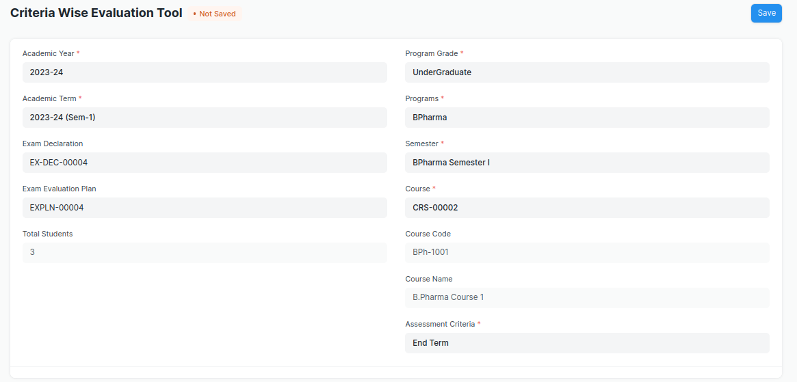
Figure 24 : Criteria Wise Evaluation Tool Screen

Field List

The “Criteria Wise Evaluation Tool” screen shall consist of the following fields:

ID | Field Label | Field Type | Validation/Action | Mandatory | Remarks | R/N/D
1 | Academic Year | Link Field | Fetched from Academic Year master screen | Y
2 | Academic Term | Link Field | Fetched from Academic Term master screen and filter applied on the basis of Academic Year | Y
3 | Exam Declaration | Link Field | Fetched from Exam Declaration master screen and filtered applied on the basis of Semester and Academic Term
4 | Exam Assessment Plan | Link Field | Fetched from Exam Assessment Plan master screen
5 | Total Students | Number
6 | Program Grade | Link Field | Fetched from Program Grades master screen |  |  | (R)  Course Grade
7 | Programs | Link Field | Fetched from Programs master screen, filtered applied on the basis of Program Grade |  |  | (R)  Courses
8 | Semester | Link Field | Fetched from Program master screen and filtered applied on the basis of Programs
9 | Course | Link Field | Fetched from Course master screen and filtered applied on the basis of Semester | Y |  | (R)  Module
10 | Course Code | Text Field | Auto fetch based on Course |  |  | (R)  Module Code
11 | Course Name | Text Field | Auto fetch based on Course |  |  | (R)  Module Name
12 | Assessment Criteria | Link Field | Fetched from Assessment Criteria master screen | Y
13 | Student Details Data | Table | HTML |  | These table is describe below

Student Details Data
ID | Field Label | Field Type | Validation/Action | Mandatory | Remarks | R/N/D
1 | Student | HTML Field | Auto fetched when all the above relevant inputs given
2 | Student Name | HTML Field | Auto fetched when all the above relevant inputs given
3 | Roll No | HTML Field | Auto fetched when all the above relevant inputs given
4 | Earned Marks | HTML Field | Auto fetched when all the above relevant inputs given
5 | Total Marks | HTML Field | Auto fetched when all the above relevant inputs given

User: Roles & Permission

The following table describes the users and their roles and permissions for the screens :

ID | Role | Select | Read | Write | Create | Delete | Submit | Cancel | Amend
1 | ToT coordinator/director | Yes | Yes | Yes | Yes | Yes | NA | NA | NA
2 | ToT coordinator/administrator | Yes | Yes | Yes | Yes | No | NA | NA | NA
3 | ToT assistant coordinator/trainer | No | Yes | No | No | No | NA | NA | NA

1.24 Continuous Evaluation
General Description
Description | Continuous Evaluation is used to assess the Assessment Criteria done for a course for an individual student.
Navigation | Home > Examination > Evaluation > Continuous Evaluation
Pre-requisites | Criteria Wise Evaluation
Existing Screen Name | Continuous Evaluation
New Screen Name | NA

Screenshot

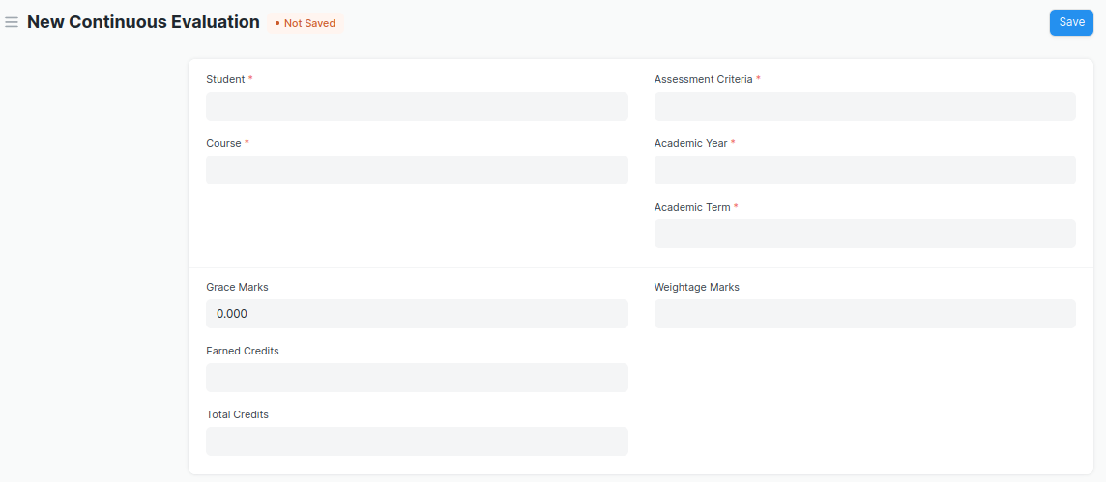
Figure 25 : Continuous Evaluation Screen

Field List

The “Continuous Evaluation” screen shall consist of the following fields:

ID | Field Label | Field Type | Validation/Action | Mandatory | Remarks | R/N/D
1 | Student | Link Field | Fetched from student master screen | Y
2 | Student Name | Text Field | Auto fetch based on Student
3 | Course | Link Field | Fetched from Course master screen | Y |  | (R) Module
4 | Roll No | Text Field | Auto fetch based on Student
5 | Registration Number | Text Field | Auto fetch based on Student
6 | Course Code | Text Field | Auto fetch based on Course |  |  | (R) Module Code
7 | Course Name | Text Field | Auto fetch based on Course |  |  | (R) Module Name
8 | Assessment Criteria | Link Field | Fetched from Assessment Criteria master screen | Y
9 | Academic Year | Link Field | Fetched from Academic Year master screen | Y
10 | Academic Term | Link Field | Fetched from Academic Term master screen | Y
11 | Get Assessments | Button | User Input
12 | Final Credit Item | Table | Child Table: Final Credit Item | Y | These table is describe below
13 | Grace Marks | Float | User Input If needed
14 | Earned Credits | Float |  |  |  | ( D )
15 | Total Credits | Float |  |  |  | ( D )
16 | Weightage Marks | Float | Fetched from Course master screen
17 | Final Marks | Float | Fetched from criteria wise evaluation screen respective record | Y
18 | Out of Marks | Float | Fetched from Course master screen

Final Credit Item
ID | Field Label | Field Type | Validation/Action | Mandatory | Remarks | R/N/D
1 | Course Assessment | Link Field | Fetched from Course Assessment master screen
2 | Earned Marks | Float | Auto Fetched from criteria wise evaluation screen respective record
3 | Grace Marks | Float | User Input If needed
4 | Total Marks | Float | Auto Fetched from criteria wise evaluation screen respective record

User: Roles & Permission
The following table describes the users and their roles and permissions for the screens :

ID | Role | Select | Read | Write | Create | Delete | Submit | Cancel | Amend
1 | ToT coordinator/director | Yes | Yes | Yes | Yes | Yes | NA | NA | NA
2 | ToT coordinator/administrator | Yes | Yes | Yes | Yes | No | NA | NA | NA
3 | ToT assistant coordinator/trainer | No | Yes | No | No | No | NA | NA | NA

1.25 Continuous Evaluation Tool
General Description
Description | Continuous Evaluation Tool is used to assess the Assessment Criteria done for a course for an individual student.
Navigation | Home > Examination > Tools > Continuous Evaluation Tool
Pre-requisites | Criteria Wise Evaluation
Existing Screen Name | Continuous Evaluation Tool
New Screen Name | NA

Screenshot

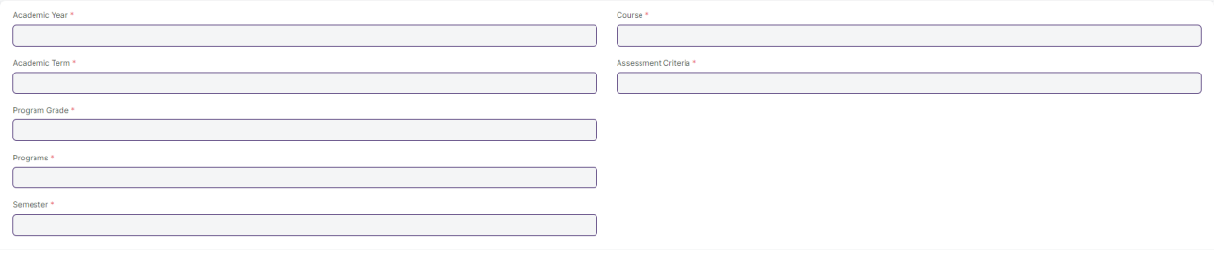
Figure 26 : Continuous Evaluation Screen

Field List

The “Continuous Evaluation Tool” screen shall consist of the following fields:

ID | Field Label | Field Type | Validation/Action | Mandatory | Remarks | R/N/D
1 | Academic Year | Link Field | Fetched from Academic Year master screen | Y
2 | Academic Term | Link Field | Fetched from Academic Term master screen and filtered applied on the basis of Academic Year | Y
3 | Program Grade | Link Field | Fetched from Program Grades master screen | Y |  | (R) Course Grade
4 | Programs | Link Field | Fetched from Programs master screen and filtered applied on the basis of Program Grades |  |  | (R) Courses
5 | Semester | Link Field | Fetched from Program master screen and filtered applied on the basis of Programs
6 | Course | Link Field | Fetched from Course master screen and filtered applied on the basis of Semester | Y |  | (R) Module
7 | Course Code | Text Field | Auto fetch based on Course |  |  | (R) Module Code
8 | Course Name | Text Field | Auto fetch based on Course |  |  | (R) Module Name
9 | Assessment Criteria | Link Field | Fetched from Assessment Criteria master screen | Y
10 | Student Inputs | HTML

Student Details Data
ID | Field Label | Field Type | Validation/Action | Mandatory | Remarks | R/N/D
1 | Student | HTML Field | Auto fetched when all the above relevant inputs given
2 | Student Name | HTML Field | Auto fetched when all the above relevant inputs given
3 | Roll No | HTML Field | Auto fetched when all the above relevant inputs given
4 | Earned Marks | HTML Field | Auto fetched when all the above relevant inputs given
5 | Total Marks | HTML Field | Auto fetched when all the above relevant inputs given

User: Roles & Permission
The following table describes the users and their roles and permissions for the screens :

ID | Role | Select | Read | Write | Create | Delete | Submit | Cancel | Amend
1 | ToT coordinator/director | Yes | Yes | Yes | Yes | Yes | NA | NA | NA
2 | ToT coordinator/administrator | Yes | Yes | Yes | Yes | No | NA | NA | NA
3 | ToT assistant coordinator/trainer | No | Yes | No | No | No | NA | NA | NA

1.26 Final Exam Result
General Description
Description | Final Exam Result is used to evaluate the final assessment of a student for a particular semester.
Navigation | Home > Examination > Evaluation > Final Exam Result
Pre-requisites | Continuous Evaluation
Existing Screen Name | Final Exam Result
New Screen Name | NA

Screenshot

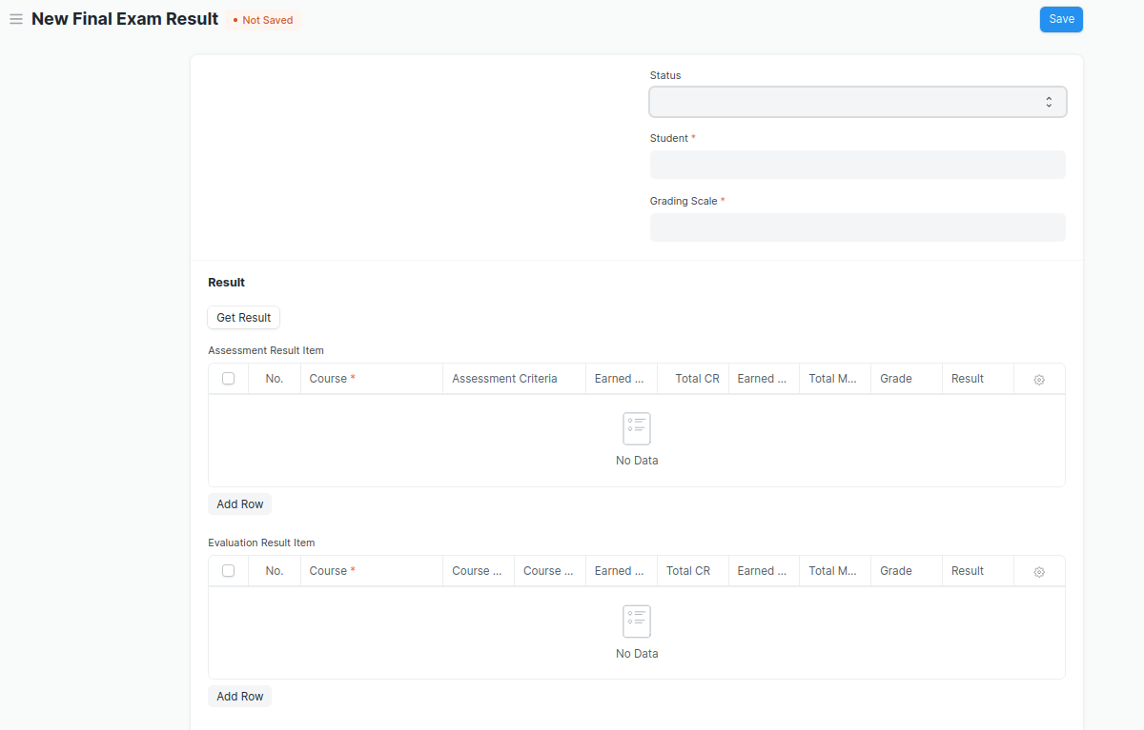
Figure 26 : Final Exam Result Screen

Field List
The “Final Exam Result” screen shall consist of the following fields:
ID | Field Label | Field Type | Validation/Action | Mandatory | Remarks | R/N/D
1 | Programs | Link Field | Auto fetch when Student Id is entered |  |  | (R) Courses
2 | Semester | Link Field | Need to be entered manually.
3 | Course | Link Field | Auto fetch when Student Id is entered |  |  | (R) Module
4 | Academic Year | Link Field | Auto fetch when Student Id is entered
5 | Academic Term | Link Field | Need to be entered manually
6 | Student | Link Field | Fetched from student master screen
7 | Student Name | Text Field | Auto fetch when Student Id is entered
8 | Roll No | Text Field | Auto fetch when Student Id is entered
9 | Registration Number | Text Field | Auto fetch when Student Id is entered
10 | Grading Scale | Link Field | Fetched from Grading Scale master screen
11 | Assessment Status | Text Field
12 | Get Result | Button
13 | Assessment Result Item | Table | After Clicking on Get Result, the Assessment Result Item table will auto fetch. |  | These table is describe below
14 | Evaluation Result Item | Table | This table will visible when a record is in Draft Status |  | These table is describe below
15 | Result | Text Field | Auto Calculated after saving the record
16 | Grade | Text Field | Auto Calculated after saving the record |  |  | (N)
17 | Overall Grade | Text Field | Auto Calculated after saving the record |  |  | (N)
18 | Comment | Small Text Field
19 | SGPA |  |  |  |  | ( D )
20 | Overall CGPA |  |  |  |  | ( D )

Assessment Result Item
ID | Field Label | Field Type | Validation/Action | Mandatory | Remarks | R/N/D
1 | Course | Link Field | Fetched from Course master screen | Y |  | (R) Module
2 | Assessment Criteria | Link Field | Fetched from Assessment Criteria master screen
3 | Earned CR | Float | Auto fetched on the basis of Get Result Button |  |  | ( D )
4 | Total CR | Float | Auto fetched on the basis of Get Result Button |  |  | ( D )
5 | Earned Marks | Float | Auto fetched on the basis of Get Result Button
6 | Total Marks | Float | Auto fetched on the basis of Get Result Button
7 | Grade | Text Field | Auto fetched on the basis of Get Result Button
8 | Result | Drop down | Auto fetched on the basis of Get Result Button | P/F

Evaluation Result Item (This table will visible when the record is in draft stage)
ID | Field Label | Field Type | Validation/Action | Mandatory | Remarks | R/N/D
1 | Course | Link Field | Fetched from Course master screen | Y |  | (R) Module
2 | Course Code | Text Field | Auto fetch based on Course |  |  | (R) Module Code
3 | Course Name | Text Field | Auto fetch based on Course |  |  | (R) Module Name
4 | Earned CR | Float |  |  |  | ( D )
5 | Total CR | Text Field |  |  |  | ( D )
6 | Earned Marks | Text Field
7 | Total Marks | Text Field
8 | Grade | Text Field
9 | Result | Drop down | P/F

User: Roles & Permission

The following table describes the users and their roles and permissions for the screens :

ID | Role | Select | Read | Write | Create | Delete | Submit | Cancel | Amend
1 | ToT coordinator/director | Yes | Yes | Yes | Yes | Yes | NA | NA | NA
2 | ToT coordinator/administrator | Yes | Yes | Yes | Yes | No | NA | NA | NA
3 | ToT assistant coordinator/trainer | No | Yes | No | No | No | NA | NA | NA

1.27 Final Result Declaration Tool
General Description
Description | Final Result Declaration Tool is used to declare the final exam results for a particular group/batch of students in a semester.
Navigation | Home > Examination > Tools > Final Result Declaration Tool
Pre-requisites | Continuous Evaluation
Existing Screen Name | Final Result Declaration Tool
New Screen Name | NA

Screenshot

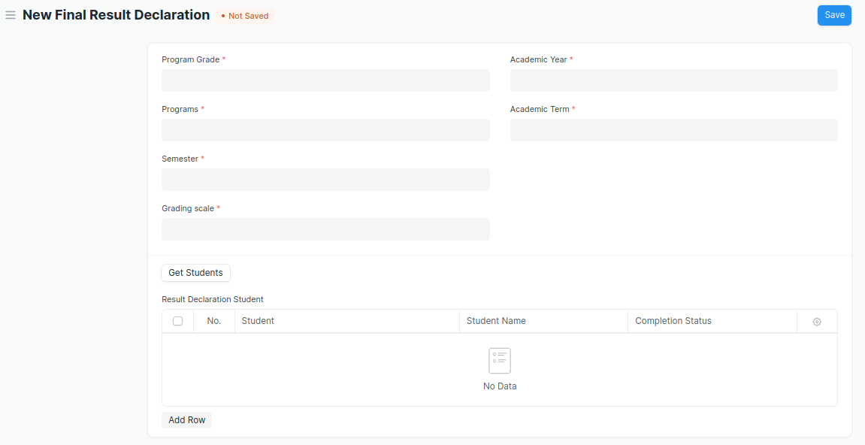
Figure 27 : Final Result Declaration Tool Screen

Field List

The “Final Result Declaration Tool” screen shall consist of the following fields:

ID | Field Label | Field Type | Validation/Action | Mandatory | Remarks | R/N/D
1 | Program Grade | Link Field | Fetched from Program Grades master screen | Y
2 | Programs | Link Field | Fetched from Programs master screen and filtered applied on the basis of Program Grade | Y
3 | Semester | Link Field | Fetched from Program master screen and filtered applied on the basis of Programs | Y
4 | Grading scale | Link Field | Fetched from Grading Scale master screen | Y
5 | Academic Year | Link Field | Fetched from Academic Year master screen | Y
6 | Academic Term | Link Field | Fetched from Academic Term master screen and filtered applied on the basis of Academic Year | Y
7 | Result Creation Status | Drop Down | In Process  Failed  Successful
8 | Get Students | Button | User Input
9 | Total Enrolled Student | Number | Auto created when clicked on Get Student Button
10 | Result Declaration Student | Table | Child Table: Result Declaration Student |  | These table is describe below

Result Declaration Student
ID | Field Label | Field Type | Validation/Action | Mandatory | Remarks | R/N/D
1 | Student | Link Field | Fetched from Student master screen
2 | Student Name | Text Field | Auto fetch based on Student
3 | Roll No | Text Field | Auto fetch based on Student

User: Roles & Permission

The following table describes the users and their roles and permissions for the screens :

ID | Role | Select | Read | Write | Create | Delete | Submit | Cancel | Amend
1 | ToT coordinator/director | Yes | Yes | Yes | Yes | Yes | NA | NA | NA
2 | ToT coordinator/administrator | Yes | Yes | Yes | Yes | No | NA | NA | NA
3 | ToT assistant coordinator/trainer | No | Yes | No | No | No | NA | NA | NA

1.28 Cumulative Marksheet
General Description
Description | Cumulative Marksheet is a compilation of all the semesters with their grades in a single certificate. The Cumulative marksheet will have a list of subjects, grades obtained and CGPA (Cumulative Grade Point Average). And also details of students, such as roll number, name, age and date of birth, program enrollment.
Navigation | Home > Examination > Transcripts > Cumulative Marksheet
Pre-requisites | Final Exam Result
Existing Screen Name | Cumulative Marksheet
New Screen Name | NA

Screenshot

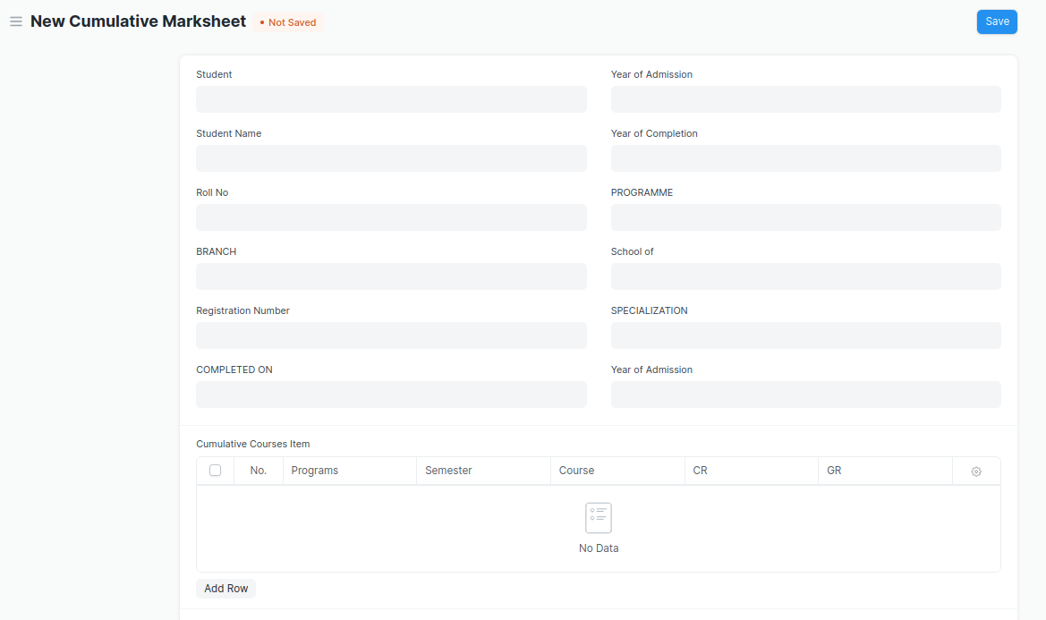
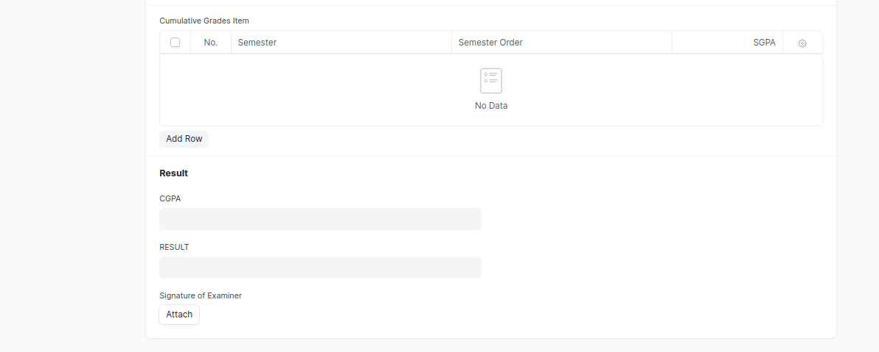
Figure 28 : Cumulative Marksheet Screen

- Remove/Hide the CGPA, SGPA, and Credit features from the Cumulative Mark sheet and display the percentage and grade instead.

Field List

The “Cumulative Marksheet” screen shall consist of the following fields:

ID | Field Label | Field Type | Validation/Action | Mandatory | Remarks | R/N/D
1 | Student | Link Field | Fetched from Student master screen
2 | Student Name | Text Field | Auto fetch based on Student
3 | Roll No | Text Field | Auto fetch based on Student
4 | BRANCH | Text Field
5 | Registration Number | Text Field | Auto fetch based on Student
6 | COMPLETED ON | Text Field
7 | Year of Admission | Link Field | Fetched from Academic Year master screen
8 | Year of Completion | Link Field | Linked with Academic Year master screen
9 | PROGRAMME | Link Field | Fetched from Programs master screen
10 | School of | Text Field
11 | Year of Admission | Text Field
12 | Cumulative Courses Item | Table | Child Table: Cumulative Courses Item |  | These table is describe below
13 | Cumulative Grades Item | Table | Child Table: Cumulative Grades Item |  | These table is describe below
14 | Overall Grade | Float
15 | RESULT | Text Field | User Input
16 | Signature of Examiner | Attach image | - On attachment a dialogue box will be popup where user can attach the files, take the picture with the help camera and can link any URL.  - If photos or images attached then the size will be maximum 200 kb

Cumulative Courses Item
ID | Field Label | Field Type | Validation/Action | Mandatory | Remarks | R/N/D
1 | Programs | Link Field | Fetched from Programs master screen
2 | Semester | Link Field | Fetched from Program master screen
3 | Course | Link Field | Fetched from Course master screen |  |  | (R) Module
4 | Course Code | Text Field | Auto fetch based on Course |  |  | (R) Module Code
5 | Course Name | Text Field | Auto fetch based on Course |  |  | (R) Module Name
6 | CR | Text Field |  |  |  | ( D )
7 | GR | Text Field |  |  |  | ( D )

Cumulative Grades Item
ID | Field Label | Field Type | Validation/Action | Mandatory | Remarks | R/N/D
1 | Semester | Link Field | Fetched from Program master screen
2 | Semester Order | Drop down | 1ST SEM  2ND SEM  3RD SEM  4TH SEM  5TH SEM  6TH SEM  7TH SEM  8TH SEM  9TH SEM  10TH SEM
3 | Grade | Text Field |  |  |  | (D) These field will be deleted

User: Roles & Permission

The following table describes the users and their roles and permissions for the screens :

ID | Role | Select | Read | Write | Create | Delete | Submit | Cancel | Amend
1 | ToT coordinator/director | Yes | Yes | Yes | Yes | Yes | NA | NA | NA
2 | ToT coordinator/administrator | Yes | Yes | Yes | Yes | No | NA | NA | NA
3 | ToT assistant coordinator/trainer | No | Yes | No | No | No | NA | NA | NA

1.29 Cumulative Marksheet Tool
General Description
Description | Cumulative Marksheet Tool is a compilation of all the semesters with their grades in a single certificate. The Cumulative marksheet will have a list of subjects, grades obtained and CGPA (Cumulative Grade Point Average). And also details of students, such as roll number, name, age and date of birth, program enrollment.
Navigation | Home > Examination > Tools > Cumulative Marksheet Tool
Pre-requisites | Final Exam Result
Existing Screen Name | Cumulative Marksheet
New Screen Name | NA

Screenshot

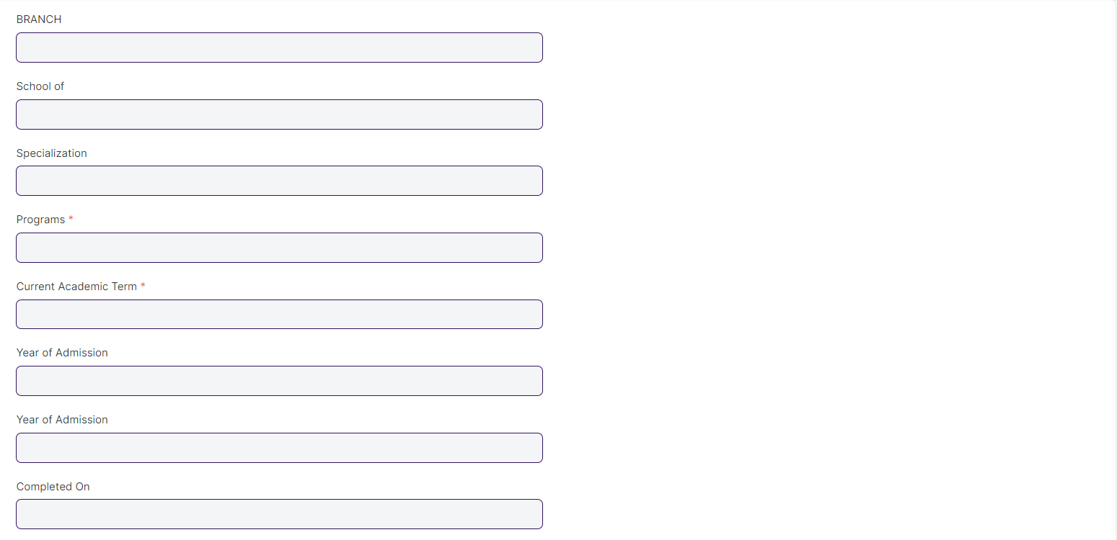
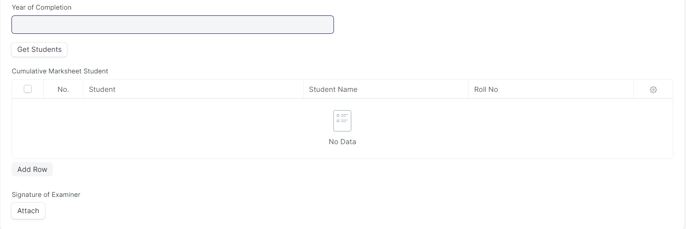
Figure 29 : Cumulative Marksheet Tool

- Remove/Hide the CGPA, SGPA, and Credit features from the Cumulative Mark sheet and display the percentage and grade instead.

Field List

The “Cumulative Marksheet Tool” screen shall consist of the following fields:

ID | Field Label | Field Type | Validation/Action | Mandatory | Remarks | R/N/D
1 | BRANCH | Text Field
2 | School of | Text Field
3 | Specialization | Text Field
4 | Programs | Link Field | Fetched from Programs master screen | Y
5 | Current Academic Term | Link Field | Fetched from Academic Term master screen | Y
6 | Year of Admission | Link Field | Fetched from Academic Year master screen
7 | COMPLETED ON | Text Field
8 | Year of Completion | Link Field | Fetched from Academic Year master screen
9 | Result Creation Status | Dropdown | In Process/Failed/  Successful
10 | Get Students | Button | On click this button Student will fetch based on Programs & Academic Term in the Cumulative Marksheet Student
11 | Total Students for Marksheet | Number
12 | Cumulative Marksheet Student | Table | Child Table: Cumulative Marksheet Student |  | These table is describe below
13 | Signature of Examiner | Attach image | - On attachment a dialogue box will be popup where user can attach the files, take the picture with the help camera and can link any URL.  If photos or images attached then the size will be maximum 200 kb

Cumulative Marksheet Student
ID | Field Label | Field Type | Validation/Action | Mandatory | Remarks | R/N/D
1 | Student | Link Field | Fetched from “Get Students” Button
2 | Student Name | Text Field | Auto fetch based on Student
3 | Roll No | Text Field | Auto fetch based on Student
4 | Registration Number | Text Field | Auto fetch based on Student

User: Roles & Permission

The following table describes the users and their roles and permissions for the screens :

ID | Role | Select | Read | Write | Create | Delete | Submit | Cancel | Amend
1 | ToT coordinator/director | Yes | Yes | Yes | Yes | Yes | NA | NA | NA
2 | ToT coordinator/administrator | Yes | Yes | Yes | Yes | No | NA | NA | NA
3 | ToT assistant coordinator/trainer | No | Yes | No | No | No | NA | NA | NA

1.30 ToT candidate list

General Description

Description | This screen is used to enter and maintain the details of eligible candidates for the ToT Program.
Navigation | NA
Pre-requisites | NA
Existing Screen Name | ToT candidate list
New Screen Name | No change

Screenshot

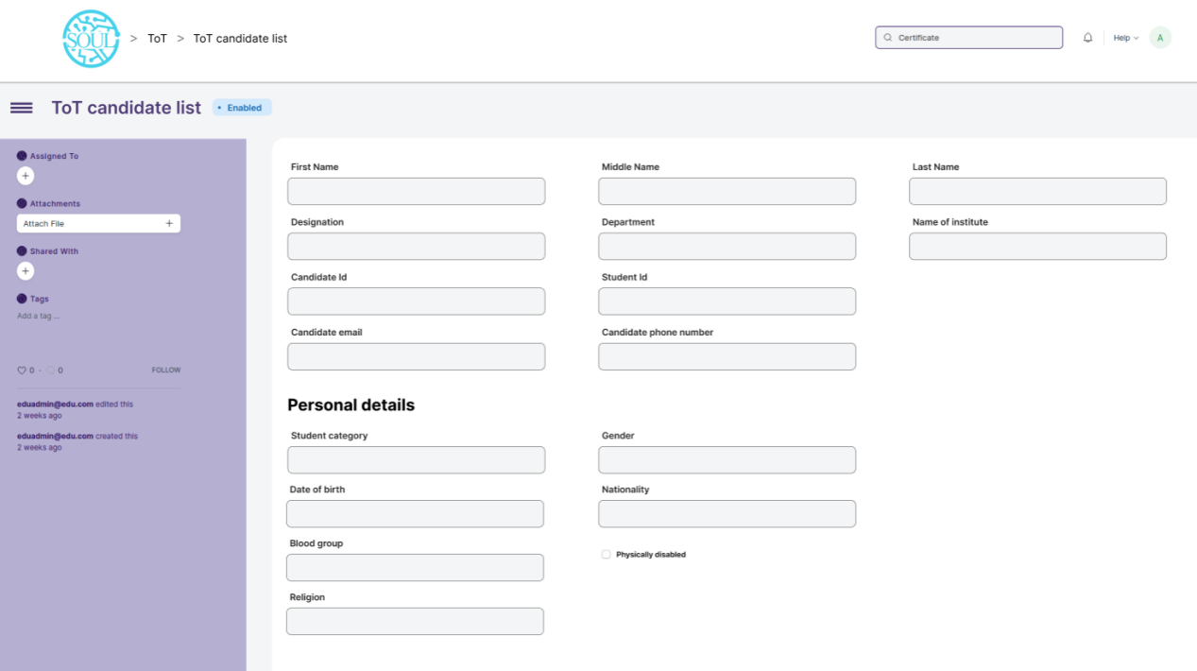
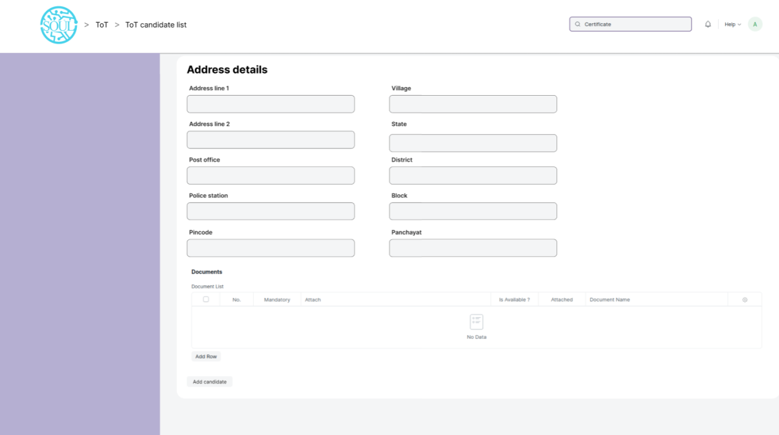
Figure 30 : ToT candidate list Screen

Field List

The “ToT candidate list” screen shall consist of the following fields:

ToT candidate list
ID | Field Label |  | Field Type |  | Validation/Action |  |  | Mandatory | Remarks |  | R/N/D
1 |  | First Name |  | Text |  | Yes
2 |  | Middle Name |  | Text
3 |  | Last Name |  | Text
4 |  | Designation |  | Text
5 |  | Department |  | Text
6 |  | Name of institute |  | Text
7 |  | Candidate ID |  | Text
8 |  | Student ID |  | Text
9 |  | Candidate email |  | Text
10 |  | Candidate phone number |  | Text
Personal Details
11 |  | Student Category |  | Link Field |  |  | Links to Student Category Screen
12 |  | Sub Tribes |  | Dropdown |  |  | - Kond  - Gabri  - Dongri  - So on……
13 |  | Date of Birth |  | Date
14 |  | Blood Group |  | Dropdown |  |  | A +ve  B +ve  AB +ve  O +ve  A -ve  B -ve  AB -ve  O -ve
15 |  | Religion |  | Link
16 |  | Gender |  | Link
17 |  | Nationality |  | Text
18 |  | Physically Disabled |  | Checkbox
Address details
19 |  | Address Line 1 |  | Text
20 |  | Address Line 2 |  | Text
21 |  | Post Office |  | Text
22 |  | Police Station |  | Text
23 |  | Pincode |  | Text
24 |  | Village |  | Text
25 |  | State |  | Text
26 |  | District |  | Text
27 |  | Block |  | Text
28 |  | Panchayat |  | Text
Documents
29 |  | Document Name |  | Link Field
30 |  | Mandatory |  | Checkbox
31 |  | Attach |  | Attachment |  |  | - On attachment a dialogue box will be popup where user can attach the files, take the picture with the help camera and can link any URL.  - If photos or images attached then the size will be maximum 200 kb.

User: Roles & Permission

The following table describes the users and their roles and permissions for the screens :

ID | Role | Select | Read | Write | Create | Delete | Submit | Cancel | Amend
1 | ToT coordinator/director | Yes | Yes | Yes | Yes | Yes | NA | NA | NA
2 | ToT coordinator/administrator | Yes | Yes | Yes | Yes | No | NA | NA | NA
3 | ToT assistant coordinator/trainer | No | Yes | No | No | No | NA | NA | NA

1.30 ToT candidate selection
General Description

Description | This screen is used to select and maintain list of candidates chosen for a particular ToT training program.
Navigation | NA
Pre-requisites | - ToT candidate list
Existing Screen Name | ToT candidate selection
New Screen Name | No change

Screenshot

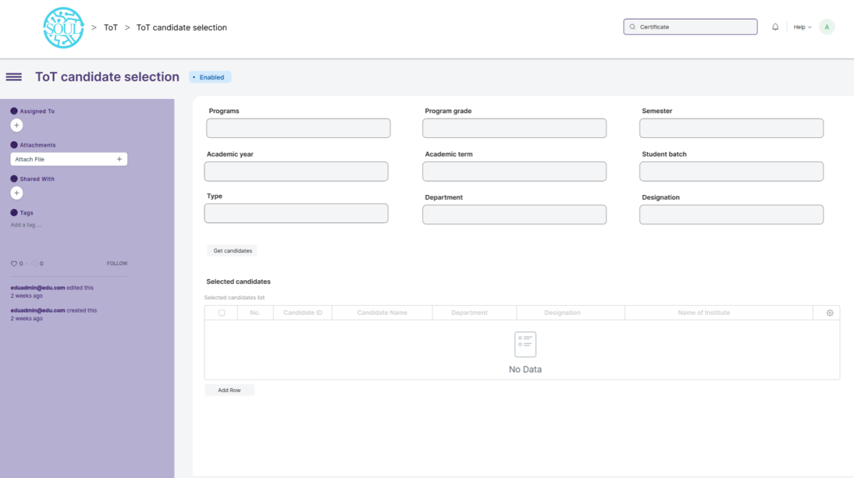
Figure 31 : ToT candidate selection

Field List

The “ToT candidate selection” screen shall consist of the following fields:

ToT candidate selection
ID | Field Label |  | Field Type |  | Validation/Action |  |  | Mandatory | Remarks |  | R/N/D
1 |  | Programs |  | Text |  | Yes
2 |  | Program grade |  | Text
3 |  | Semester |  | Text
4 |  | Academic year
5 |  | Academic term
6 |  | Student batch
7 |  | Candidate ID
8 |  | Type
9 |  | Department
10 |  | Designation
Personal Details
11 |  | Candidate ID |  | Link Field |  |  | Links to Student Category Screen
 |  | Candidate name
 |  | Department
 |  | Designation
 |  | Name of institute

User: Roles & Permission

The following table describes the users and their roles and permissions for the screens :
ID | Role | Select | Read | Write | Create | Delete | Submit | Cancel | Amend
1 | ToT coordinator/director | Yes | Yes | Yes | Yes | Yes | NA | NA | NA
2 | ToT coordinator/administrator | Yes | Yes | Yes | Yes | No | NA | NA | NA
3 | ToT assistant coordinator/trainer | No | Yes | No | No | No | NA | NA | NA

1.31 ToT candidate reporting
General Description

Description | This screen is used for marking a candidate/trainee as present after they have reported on the day of reporting
Navigation | NA
Pre-requisites | - ToT candidate selection
Existing Screen Name | ToT candidate reporting
New Screen Name | No change

Screenshot

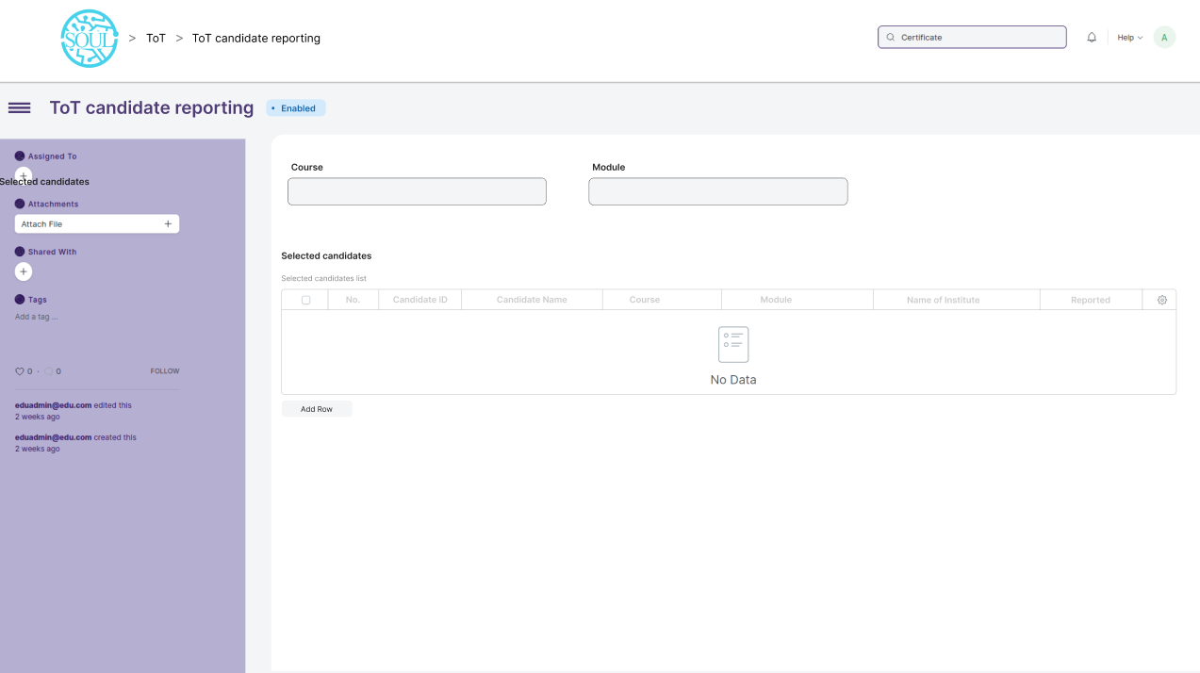
Figure 32 : ToT candidate reporting

Field List

The “ToT candidate reporting” screen shall consist of the following fields:

ToT candidate reporting
ID | Field Label |  | Field Type |  | Validation/Action |  |  | Mandatory | Remarks |  | R/N/D
1 |  | Course |  | Text |  | Yes
2 |  | Module |  | Text
Personal Details
11 |  | Candidate ID |  | Link Field |  |  | Links to Student Category Screen
 |  | Candidate name |  | Text
 |  | Department |  | Text
 |  | Designation |  | Text
 |  | Name of institute |  | Text
 |  | Reported |  | Checkbox

User: Roles & Permission

The following table describes the users and their roles and permissions for the screens :

ID | Role | Select | Read | Write | Create | Delete | Submit | Cancel | Amend
1 | ToT coordinator/director | Yes | Yes | Yes | Yes | Yes | NA | NA | NA
2 | ToT coordinator/administrator | Yes | Yes | Yes | Yes | No | NA | NA | NA
3 | ToT assistant coordinator/trainer | No | Yes | No | No | No | NA | NA | NA

